Name: ______________________________

Algebra II

Unit 7:
Quadratic Equations
and Functions

Priority Standards: A-REI.4: Solve quadratic equations in one variable.

F-IF.8A: Use the process of factoring and completing the square in a quadratic function to show zeros, extreme values and symmetry of the graph and interpret these in terms of a context.

Unit “I can” statements:
- I can solve quadratic equations by completing the square.
- I can solve quadratic equations and applications by using the quadratic formula.
- I can use the discriminant to determine the nature of the roots of a quadratic equation.
- I can graph quadratic functions by rewriting the equations into vertex form.
- I can write the equation for a parabola when given three points on the parabola.
- I can solve quadratic function applications.

Completing the Square

In this unit, we will be investigating quadratic equations and functions. Just like all linear functions could be written in the form $=mx+b$ , all quadratic functions can be written in the form:

$$y=ax^{2}+bx+c, where a, b, and c∈reals.$$

In this unit, we will learn how to solve, graph, and apply quadratic functions. The first technique that we will learn in this unit for solving quadratics is called completing the square. First we should consider quadratics that you already know how to solve.

Break for Practice: Solve

1.$x^{2}= 25$ 2. $x^{2}= 12$

3. ${\left(x-2\right)}^{2}=5$ 4. ${\left(5x+4\right)}^{2}=-36$

If we can transform a quadratic into the above form, then we can solve it. This needed technique is called completing the square.

Example: Solve by completing the square.
Steps:

- Isolate the constant on one side.

- Divide through by the coefficient of x² and add a blank to both sides.

- Add to both sides (fill in the blanks) the square of half of the coefficient of x.

- Write in the form ${\left(x±q\right)}^{2}=r$ .

- Solve.

Note: The Ancient Babylonians knew how to do all of this with pictures!

$x^{2}+12x-45=0$

Break for Practice: Solve by completing the square.

1. ${2x}^{2}-8x-12=0$ 2. ${3x}^{2}-10=12x$

Extended Practice:

1. Solve each equation.

a.) $x^{2}=3$ | b.) ${\left(x-1\right)}^{2}=3$ | $$c.) {\left(2x-1\right)}^{2}=3$$
d.) $x^{2}=-4$ | e.) ${\left(x+7\right)}^{2}=-4$ | $$f.) {\left(2x+7\right)}^{2}=-4$$

2. Solve by completing the square.

a.) $x^{2}-2x-5=0$ | b.) $y^{2}+6y-2=0$
c.) $t^{2}+8=4t$ | d.) ${3n}^{2}+12n=-1$

The Quadratic Formula

In this section we will learn a more efficient method for solving quadratic equations. It is a formula derived from the method of completing the square.

Quadratic Formula: If ${ax}^{2}+bx+c=0$, then

x =

Note – In order to use this formula, the problem needs to be in the form ${ax}^{2}+bx+c=0.$

Break for Practice: Solve each equation by using the quadratic formula.

1. ${2x}^{2}-3x-5=0$ 2. $k^{2}-6k-1=0$

3.${3x}^{2}=-2x-1$ 4. $\left(3x-1\right)\left(x+4\right)=-9$

Extended Practice: Solve each equation using the quadratic formula. Give answers involving radicals in simplest radical form.

1. ${5k}^{2}+3k-2=0$ | 2. ${2p}^{2}-3p-2=0$
3. ${5r}^{2}+8=-12r$ | 4. ${2w}^{2}+4w=-3$
5. $2x\left(x+1\right)=7$ | 6. $5=4r\left(2r+3\right)$
7. $\left(3n-5\right)\left(2n-2\right)=6$ | 8. $\left(2x+1\right)\left(2x-1\right)=4x$
Applications with Quadratic Equations

Now it’s time to see where quadratic equations might be used.

Break for Practice: Solve

- A flower garden with dimensions of 8 meters by 10 meters is enclosed by a walkway of uniform width. If the area of the walkway is 40 square meters, then what is the width of the path?

- A rectangle is 6 cm long and 5 cm wide. When each dimension is increased by x cm, the area is tripled. Find the value of x.

- A rectangular animal pen with an area of 1200 square meters has one side along a barn. The other three sides are enclosed by 100 meters of fencing. Find the dimensions of the pen.

Extended Practice: Solve

1. Each side of a square is 4 meters long. When each side is increased by x meters, the area is doubled.
Find the value of x.

2. A rectangular field with area 5000 square meters is enclosed by 300 meters of fencing. Find the dimensions of the field.

3. A walkway of uniform width has area 72 meters squared and surrounds a swimming pool that is 8 meters wide and 10 meters long. Find the width of the walkway.

4. A 5 inch by 7inch photograph is surrounded by a frame of uniform width. The area of the frame equals the area of the photograph. Find the width of the frame.

The Discriminant

In certain situations, it is not necessary to actually solve a quadratic equation, but it is useful to know what kind of solutions (roots) it has. To do this, you need to be able to use the discriminant test.

Consider the following four problems. Each one gives a different type of solution. Solve each with the quadratic formula, and then try to figure out what part of the quadratic formula determines the nature of the solutions.

1. ${2x}^{2}-8x+8=0$ 2. $x^{2}-x-12=0$

3. $x^{2}-2x+2=0$ 4. $x^{2}-4x-3=0$

Result: The Discriminant, D = ____________________

- If $D<0$ , then there are ___________________________________________________

- If $D=0$ , then there is ___________________________________________________

- If $D>0$ and a perfect square, then there are ___________________________________

- If $D>0$ but not a perfect square, then there are _________________________________

Beak for Practice: Use the discriminant to identify the type of solutions for each equation.

1. $x^{2}+10x+25=0$ 2. ${5x}^{2}-6x+2=0$

3. ${3x}^{2}-4x-7=0$ 4. $\frac{x^{2}}{6}+1=x$

5. Find the value(s) of k for which the equation ${2x}^{2}+4x+k=0$ has the following.

- One real double root. b) Two different real roots

c) Two imaginary roots

Extended Practice:

Use the discriminant to identify the type of solutions for each equation.

1. $x^{2}+3x-9=0$ | 2. $x^{2}-4x-5=0$ | 3. $t^{2}+8t+20=0$
4. ${3m}^{2}-8m-5=0$ | 5. ${2y}^{2}-9y+3=0$ | 6. ${5t}^{2}-4t+3=0$
7. $z^{2}+\frac{5}{4}=z$ | 8. $\frac{r^{2}}{4}+1=r$

Solve each equation using whichever method seems easiest to you.

9. $x^{2}-6x+5=0$ | 10. $y^{2}+2y-24=0$
11. $5({x+7)}^{2}=0$ | 12. $5{\left(x+7\right)}^{2}=25$
13. $\left(2x+5\right)\left(X-3\right)=0$

14. Find the value(s) of k for which the equation ${3x}^{2}-6x-k=0$ has the following.

a) One real double root. b) Two different real roots

c) Two imaginary roots

Introduction to Graphs of Quadratic Functions

In this section we will begin exploring the graphs of quadratics. We will use graphing calculators/computers in this section, and in future sections we will learn useful techniques that we can do by hand.

Definition: Quadratic Functions are functions in the form $y={ax}^{2}+bx+c$, when
$a, b, and c are constants but a≠0$

The shape of the graph of a quadratic function is called a _____________________.

Review: Sketch $y=x^{2}$

Use the graphing calculator/computer to make quick sketches for the following.
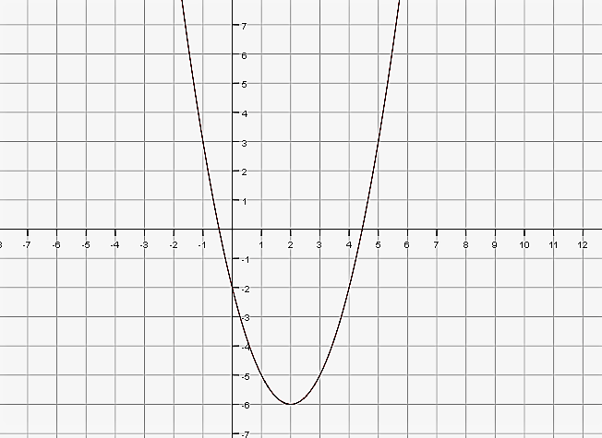
$$y={2x}^{2}$$ | $$y={-3x}^{2}$$ | $$y=\frac{1}{2}x^{2}$$ | $$y=x^{2}-5$$
$${y=x}^{2}+3$$ | $$y={\left(x-2\right)}^{2}$$ | $$y={\left(x+3\right)}^{2}$$ | $$y=-3{\left(x+4\right)}^{2}+5$$
Break for Practice: Quickly sketch parabolas from the following information.

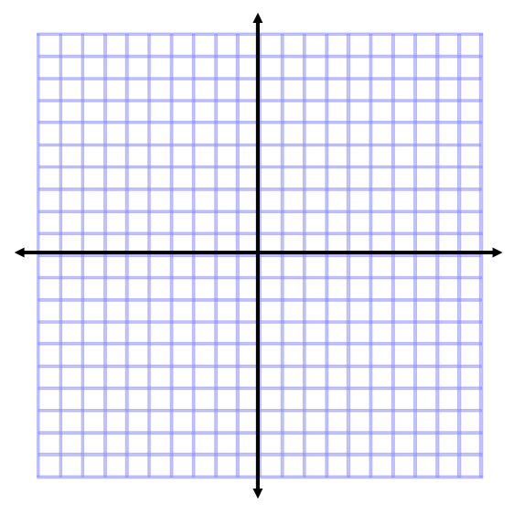
1.$vertex= (2, 1$) 2. $vertex= (-2, -3)$
$y-intercept = 3$ $x-intercept = 1$

3. $vertex= \left(4, 3\right)$ 4. $vertex= (-3, 5)$
$y-intercept = -3$ $x-intercept =2$

Extended Practice: Sketch the graph of the quadratic function with the given vertex and intercept.

1. Vertex = (2, 3) y-intercept = 7 | 2. Vertex = (-3, 2) y-intercept = -4
3. Vertex = (-3, -6) y-intercept = -4 | 4. Vertex = (-3, -4) x-intercept = 2
5. Vertex = (3, 4) x-intercept = 1 | 6. Vertex = (3, -1) y-intercept = -6
Graphing Parabolas

It is possible to find the vertex of a parabola quickly when the equation is written in a form such as
$y-5=3{\left(x-4\right)}^{2}$. This form is similar to the point-slope form of the linear function equation, except that the (x – 4) is squared.

a) Transform the above quadratic function to the form $y={ax}^{2}+bx+c .$

b) Complete the table for the above equation, and use these points to plot the parabola on the axes.
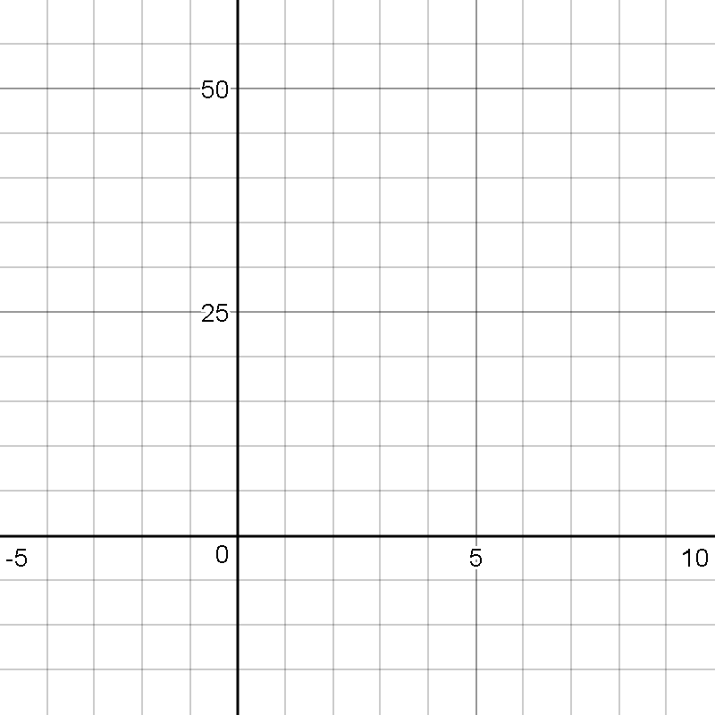
X | Y
0
1
2
3
4
5
6

c) Mark the vertex on the graph, and write down the ordered pair.

d) Where do the coordinates of the vertex show up in the equation?

e) How could you find the values of y for x = 7, and x = 8 without substituting these numbers into the
equation?
From the previous activity, you saw that equations in the form $y-k=a{\left(x-h\right)}^{2}$ were easy to identify the coordinates of the vertex. This form is called vertex form $y-k=a{\left(x-h\right)}^{2}$.

We will now learn how to transform an equation from $y={ax}^{2}+bx+c$ form into vertex form. We will also learn how to graph it by finding the y-intercept, the vertex, the axis of symmetry, and the x-intercept(s).

Example: Consider the function$y=x^{2}+10x+21$.

- Identify the y-intercept.

- Transform the equation to vertex form by completing the square.

- Identify the coordinates of the vertex.

- Identify the equation for the axis of symmetry

- Identify the x-intercept(s).
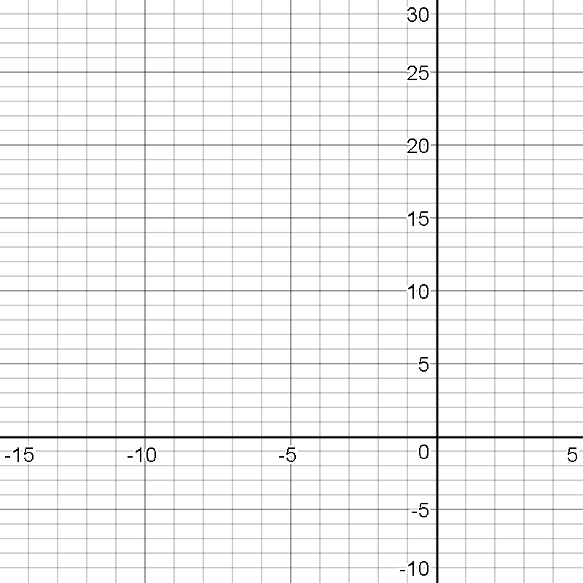

- Graph

Break for Practice: Use the method of completing the square to find each of the requested pieces of information, and graph the parabola.

$$y=x^{2}+6x+13$$ | y-intercept  Vertex  Axis of Sym.  x-intercept(s) | 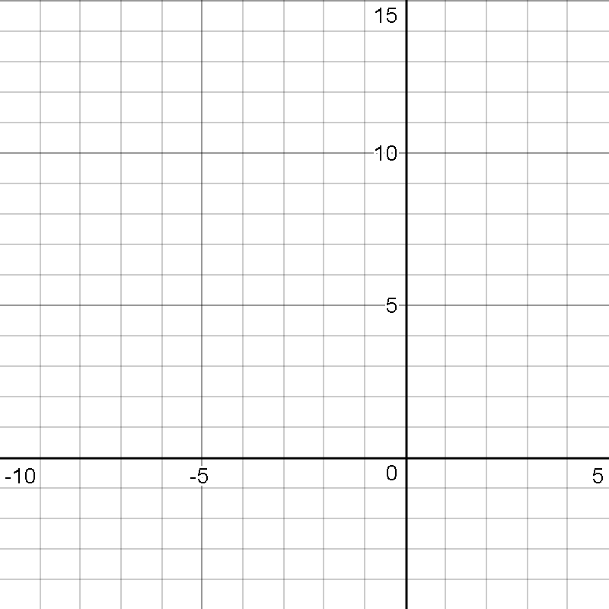

Extended Practice: Use the method of completing the square to find each of the requested pieces of information, and graph the parabola.

$$1. y=x^{2}-6x+8$$ | y-intercept  Vertex  Axis of Sym.  x-intercept(s) | 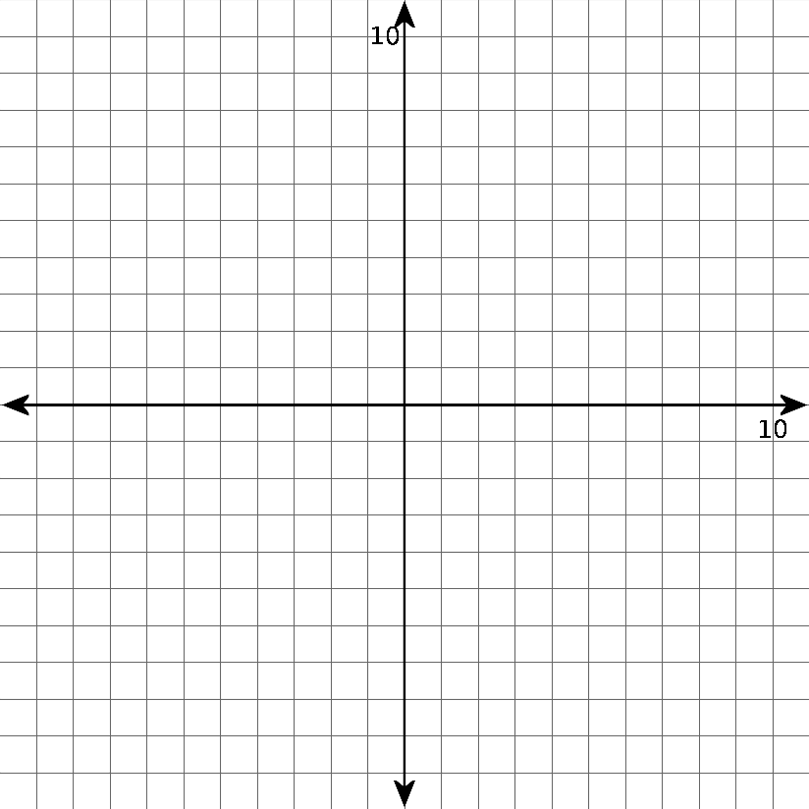
$$2. y=x^{2}-8x+7$$ | y-intercept  Vertex  Axis of Sym.  x-intercept(s)
$$3. y=x^{2}+4x+8$$ | y-intercept  Vertex  Axis of Sym.  x-intercept(s)
Next we should see what we need to adjust to work with equations that have a coefficient in front of the x²

Break for Practice: Complete the following.

$$1. y={3x}^{2}+30x+72$$ | y-intercept  Vertex  Axis of Sym.  x-intercept(s) | 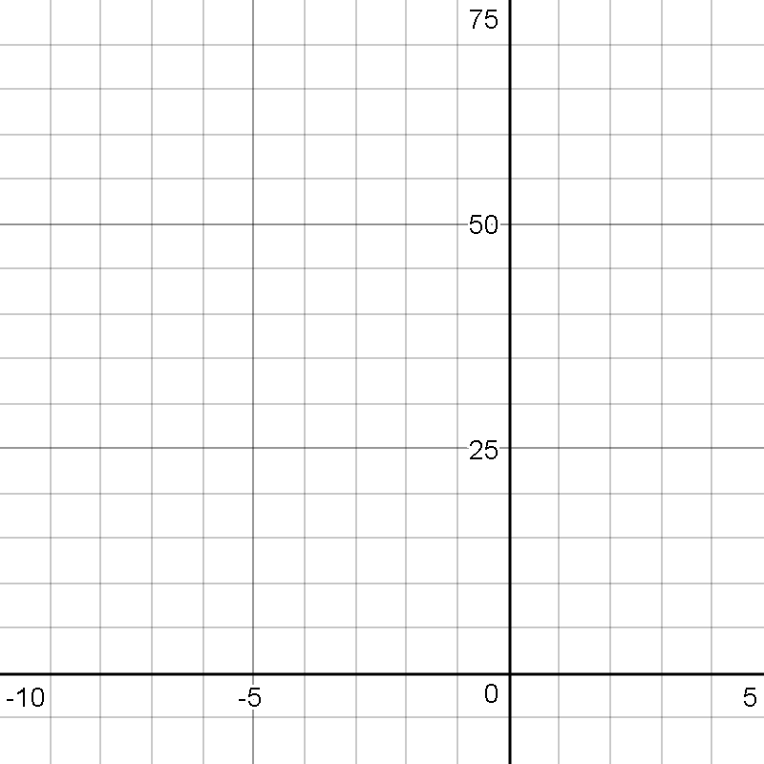
$$2. y={-3x}^{2}+12x-42$$ | y-intercept  Vertex  Axis of Sym.  x-intercept(s) | 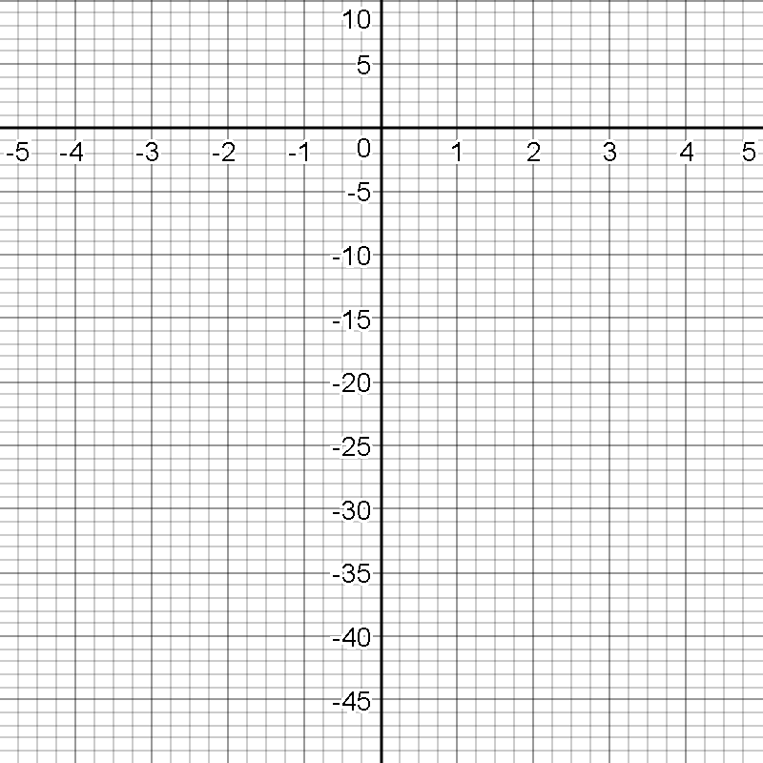
Extended Practice: Complete the following.

$$1. y={2x}^{2}+12x+10$$ | y-intercept  Vertex  Axis of Sym.  x-intercept(s)
$$2. y={-x}^{2}+4x-3$$ | y-intercept  Vertex  Axis of Sym.  x-intercept(s)
Finding Quadratic Equations from Points

Earlier in the year we learned how to find an equation for a line in the form $y=mx+b$
if we knew the coordinates for two points on the line. In this section we will learn how to find the equation for a parabola in the form $y={ax}^{2}+bx+c$ if we know the coordinates for three points on the line.

Example: Find the equation for the parabola that passes through the points $\left(-1, 6\right), \left(-2, 17\right), and \left(2, 9\right).$
Matrix A (x)
[ ]
Matrix B (y)
[ ]
${ax}^{2}+bx+c=y$

$(-1, 6)$ ______________________________

$(-2, 17)$ _____________________________

$(2, 9)$ _______________________________

Calculator Instructions: We are calculating ${[A]}^{-1}×[B]$
1
2nd

$$x^{-1}$$
Press (Edit is highlighted) Make the matrix ____x ____

Enter matrix information
2

$$x^{-1}$$
2nd
Press (Edit is highlighted) Make the matrix ____x ____
Mode
2nd
Enter matrix information (To get to home screen )
$$x^{-1}$$
2nd
1
$$×$$
$$x^{-1}$$
Press (Names is highlighted) (will be back to home screen)
Enter
$$x^{-1}$$
2nd
2
Then (Names is highlighted) (will be back to home screen)

${\left[A\right]}^{-1}∙\left[B\right]$=[ ] Answer Matrix

The equation that contains $\left(-1, 6\right), \left(-2, 17\right), and \left(2, 9\right)$ is _________________________________

Break for Practice:

- Find the equation for the parabola that contains the points $\left(-2, -11\right), \left(4, 13\right), and \left(6, 29\right).$

Extended Practice: Find the equations $(y=ax^{2}+bx+c)$ that contain the following points.

$$1. \left(1, 6\right), \left(3, 26\right), \left(-2,21\right)$$ | 2. $\left(-2,-41\right), \left(-3,-72\right), \left(5,-48\right)$
3. $\left(10,40\right), \left(-20,160\right), \left(-5,10\right)$ | 4. $\left(-4,-37\right), \left(2,11\right), \left(0,-1\right)$
5. $\left(4, 7.3\right), \left(6, 12.7\right), (-3, 1.0)$ | 6. $\left(0, 0\right), \left(-1, 7\right), (6, 42)$
Quadratic Applications

For the half time entertainment at a basketball game, a student agrees to be shot out of a cannon through an enlarged basketball hoop and into a tub of water. The person in the cannon is 3 feet off of the ground. The basketball hoop is 55 feet away and 14 feet off of the ground. The surface of the tub of water is 60 feet away and 3 feet off of the ground.

- Another student, being a curious young mathematician, quickly finds the equation for this function.

What kind of function is this?_______________________
Sketch a graph with the given points and then find the equation ____________________________

- Four feet in front of the tub of water, the team lines up. One player is six feet six inches tall. Is he in danger of being hit?

- The roof is at 35 feet. Is the student being shot from the cannon safe?

Extended Practice:

- Assume that the number of liters of water remaining in the bathtub varies quadratically with the number of minutes, which have elapsed since you pulled the plug.

- If the tub has 38.4, 21.6, and 9.6 liters remaining at 1, 2, and 3 minutes respectively, since you pulled the plug, write an equation expressing liters in terms of time.

- How much water was in the tub when you pulled the plug?

- When will the tub be empty?

- Why is a quadratic function more reasonable for this problem than a linear function would be?

- Suppose that you are an actuary for an insurance agency. Your company plans to offer a senior citizen’s accident policy, and you must predict the likelihood of an accident as a function of the driver’s age. From previous accident records, you find the following information:

Age | Accidents per 100 million kilometers driven
20 | 440
30 | 280
40 | 200

You know that the number of accidents per 100 million kilometers driven should reach a minimum then go up again for very old drivers. Therefore, you assume that a quadratic function is a reasonable.

- Write the particular equation expressing accidents per 100 million kilometers in terms of age.

- How many accidents per 100 million kilometers would you expect for an 80-year-old driver?

- Based on your model, who is safer; a 16-year-old driver or a 70-year-old driver?

- What age driver appears to be the safest?

- Your company decides to insure licensed drivers up to the age where the accident rate reaches 830 per 100 million kilometers. What is the domain of this quadratic function?

