Algebra 1b- Mrs. Tilus Name: _______________________________________
Unit 6- Part 1 Review: Parallel/Perpendicular Lines and Systems of Equations

Are the line parallel, perpendicular, or neither?

1. $\begin{matrix}y=7x-3 \\ y=\frac{-1}{6}x+10\end{matrix}$ 2. $\begin{matrix} y=x+9 \\ y=-x+7\end{matrix}$ 3. $\begin{matrix}8x-2y=3 \\ x+4y=-1\end{matrix}$

4. $\begin{matrix}y=3x+2 \\ 2y=6x-10\end{matrix}$ 5. $\begin{matrix}y=6 \\ x=-2\end{matrix}$ 6. $\begin{matrix}3y=-x \\ 3x=y\end{matrix}$

7. Which of the following lines is parallel to $=-\frac{5}{7}x+2$ ?
A.) $y+\frac{5}{7}x=-5$ B.) $y=\frac{5}{7}x$+6 C.) $y=-\frac{7}{5}x-3$ D.) $y-\frac{5}{7}x=9$

8. Which of the following lines is perpendicular to $y=\frac{2}{3}x-7$?
A.) $y=-\frac{2}{3}x-7$ B.) $y=\frac{3}{2}x+2$ C.) $y=-\frac{3}{2}x+7$ D.) $y=\frac{2}{3}x+1$

9. The line $y=-\frac{1}{2}x+3$ is perpendicular to which line?
A.) $y=-\frac{1}{2}x+6$ B.) $y=2x-3$ C.) $y=\frac{1}{2}x+1$ D.) $y=-2x$

10. Fill in the chart

Type of Solution | What is looks like using Elimination/Substitution | What is look like using Graphing
A.REI.C.6 – I can Solve systems of linear equations exactly and approximately (e.g., with graphs), focusing on pairs of linear equations in two variables.

Solve the system of equations using substitution.

10.) $3x+2y=10$ 11.) $y=3x-4$
$x+y=10$ $-6x+2y=-8$

Solve the system of equations using elimination.

12.) $-3x+5y=45$ 13.) $x-2y=16$
$3x+13y=9$ $2x-4y=8$

14.) $4x-3y=8$ 15.) $4x+5y=22$
$2x+y=14$ $5x-y=13$

Solve the system of equations using any method.

16.) $y=x+2$ 17.) $3x-2y=1$
$2x+y=11$ $4y=7+3x$

Solve the system of equations by using graphing.

18.) $\begin{matrix}y=2x-1 \\ y=\frac{1}{2}x+2\end{matrix}$ 19.) $\begin{matrix}-2y=-x-6 \\ 3x-y=7\end{matrix}$

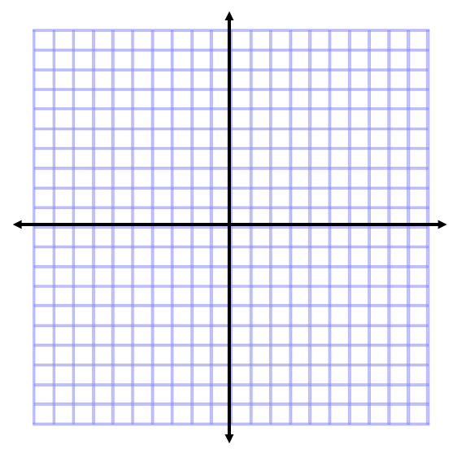

20.) $y=3x-4$ 21.) $-3x+4y=24$
$y=-\frac{1}{2}x+3$ $y=3$

