Algebra 1b- Mrs. Tilus Name_________________________________

Unit 6- Day #6: Solving Systems of Equations Review

1. Solve the system by **graphing** (get equations in slope-intercept form).

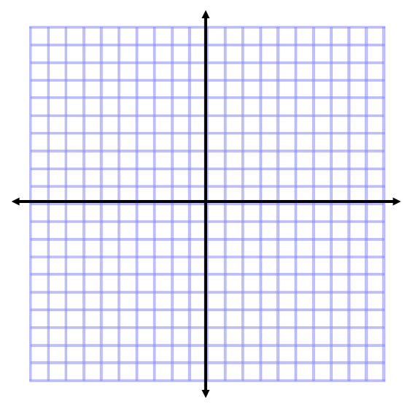 

Solution: ________________

2. Solve the system by **substitution.** 3. Solve the system by **elimination.**

 

Solution: ________________ Solution: ________________

4. Solve the system by **graphing** (get equations in slope-intercept form).

 

Solution: ________________

5. Solve the system by **substitution.** 6. Solve the system by **elimination.**

 

Solution: ________________ Solution: ________________

7. Solve the system by **graphing** (get equations in slope-intercept form).

 

Solution: ________________

8. Solve the system by **substitution.** 9. Solve the system by **elimination.**

 

Solution: ________________ Solution: ________________

10. Solve the system by **graphing** (get equations in slope-intercept form).

 

Solution: ________________

11. Solve the system by **substitution.** 12. Solve the system by **elimination.**

 

Solution: ________________ Solution: ________________