Unit 6- Solving Systems of Equations Review Card #1:
1. $y=-\frac{1}{2}x-1$ 2. $2y=-5x+8$
$y=\frac{1}{4}x-4$ $y=-\frac{5}{2}x+4$

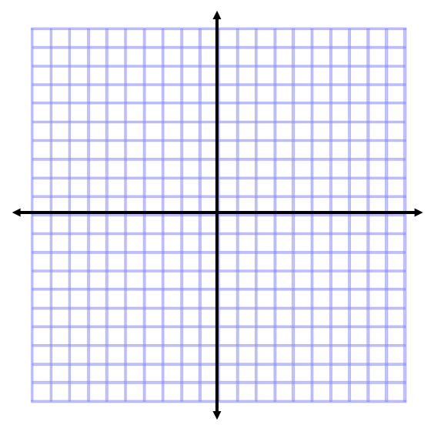

3. $y=4$ 4. $3x-2y=6$
$2x+2y=10$ $x+y=2$

Unit 6- Solving Systems of Equations Review Card #2:
Use Substitution to solve the following systems of equations.
1. $y=2x$ 2. $y=x+1$
$x+y=9$ $x+y=5$

Use Elimination to solve the following systems of equations.
3. $x+y=2$ 4. $x+6y=10$
$x-y=10$ $x+2y=2$

Unit 6- Solving Systems of Equations Review Card #3:
Use Substitution to solve the following systems of equations.
1. $2x+y=9$ 2. $x-5y=8$
$y+2x=7$ $4x+2y=10$

Use Elimination to solve the following systems of equations.
3. $3x+y=7$ 4. $2x-5y=9$
$6x+2y=14$ $5x-7y=-5$

