Algebra 1B: Mrs. Tilus Name:_________________________
Unit 6- Day 3: Solving Systems of Equation using Graphing Worksheet

Solve the following systems of linear equations by graphing.

1.) $y=3x-2$ 2.) $y=-2x+3$
$y=\frac{1}{2}x+3$ $y=2x-9$

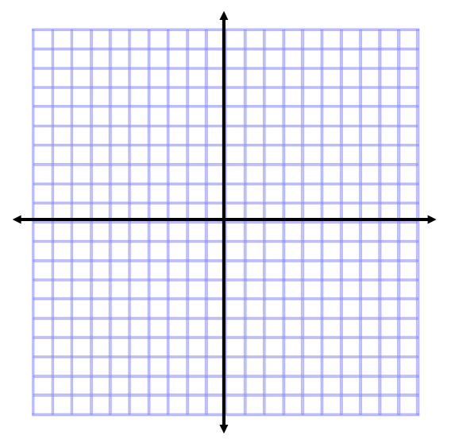

3.) $y=-\frac{1}{4}x+1$ 4.) $y=-3x+9$
$y=2x-8$ $y=2x-1$

5.)$4x+6y=-12$ 6.) $y=3$
$2x+3y=6$ $x-y=-4$

7.) $4x-2y=-8$ 8.) $2x-y=2$
$y=2x+4$ $x=3$

