Algebra II- Mrs. Tilus Name ________________________________
Unit 3-Part II: Review
Prepare well. -ELK

1. A roller rink charges a certain fixed amount to rent their facilities, and a separate amount for each guest. A party for 52 people cost $410, and another party for 84 people cost $578. Find the fixed amount to rent the rink, and the amount charged for each guest. Show your work and label your answer!

Equation #1______________________________

Equation #2: ______________________________

The fixed amount to rent the rink is _____________, and they charge _____________ for each guest.

2. Traveling downstream, a boat can cover 16 kilometers in 2 hours. Going upstream, it can make only ¾ of this distance in 2 hours. What is the rate of the boat in still water and what is the rate of the current? Show your work and label your answer!

Equation #1______________________________

Equation #2: ______________________________

The rate of the boat in still water is _____________, and the rate of the current is _____________ .

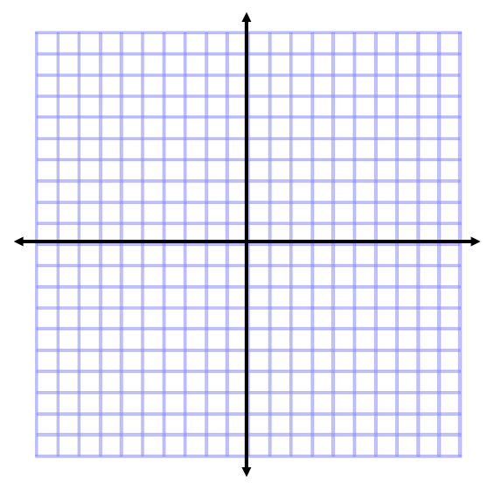
3. Graph the solution set to the system of inequalities. Shade what is true.

$2x+3y≥6$
$2x-y<7$

4. You own a small greenhouse and plan to raise carnations and daisies. Let x=carnations, and y=daisies. Write an inequality for each of the following restrictions. Graph each inequality, and shade what is false.
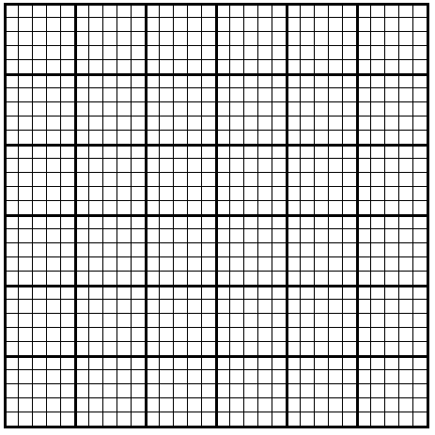
30
50
10
30
10
50
a.) The most you can plant is 46 plants total.

b.) You must have at least 12 plants of each kind.
(Hint:You need two inequalities for this part.)

c.) The number of daisies must be greater than
or equal to 2/3 times the number of
carnations.

5. The following graph has been completed for a poultry farm. The number of geese is on the x-axis, and the number of turkeys is on the y-axis. The feasible region is shaded. A goose brings in a profit of $2.00 and a turkey brings in a profit of $3.00.
a.) Write the equation representing total profit
In terms of geese and turkeys.

20

b.) Find the coordinates of the point for
the maximum profit.

10

20
10

c.) What is the profit at this point?

