Algebra II- Mrs. Tilus Name __________________________________
Unit 3- Part I Review
The happiest people don’t have the best of everything… they just make the best of everything they have.

1. Match each term with the correct example.
A. Same line | $$3x+y=5 and 6x+2y=10$$
B. Perpendicular Lines | $$2x+y=3 and x-2y=10$$
C. Intersecting Lines  (not perpendicular) | $$y=2x+3 and y=-x+4$$
D. Parallel Lines | $$y=2x+3 and y=2x-8$$

2. Classify each of the following as true or false, and correct the false statements.

a.) A vertical line has a zero slope. 2a.) ____________

b.) As a line is viewed left to right, a negative slope is indicated by a falling line. 2b.) ____________

c.) A horizontal line has an undefined slope. 2c.) ____________

d.) If the system has no solution, the equations are parallel. 2d.) ____________

e.) If the graphs are perpendicular, then no ordered pairs satisfy the 2e.) ____________
system of equations.

f.) If a system has exactly one solution, then the equations are the same line. 2f.) ____________

g.) If the equations are the same line, the system has an infinite number of solutions. 2g.) ____________

3. When you solve a system of equations, what does your answer represent? What are the different types of solutions?

4. (5pts each) Solve each system of equations by using the graphing method. Show your work! Write the solution below.
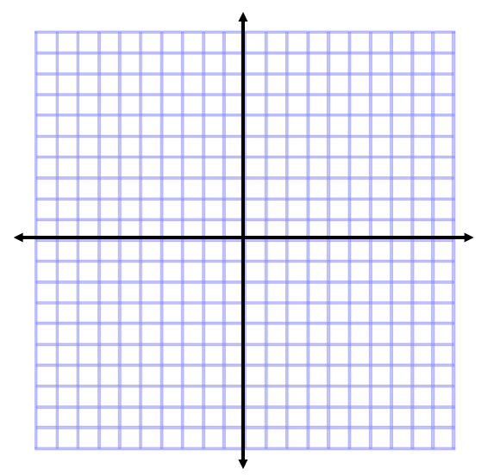
a.) $2x – 2y = 6$ 4a.) Solution: ___________
$x = 2$

b.) $y = -\frac{1}{2} x + 4$ 4b.) Solution: __________
$x + 2y = 8$

c.) $3x = 2y + 2$
$2x – y = 4$ 4c.) Solution: ___________

5. (6pts each) Solve the system of equations and then circle which method you used. Use linear combination at least once, and substitution at least once.
a.) $2x + 5y = 41$ 5a.) _____________
$2x + y = 13$
I used: Elimination
Substitution

b.) $3x + 4y = 2$ 5b.) _____________
$2x – 5y = 9$
I used: Elimination
Substitution

c.) $5(3 – x) = -2y + 1$ 5c.) _____________
$3(5 – x) = y$
I used: Elimination
Substitution

d.) 3(x + 2) = y + 7 5d.) _____________
–6x + 2y = – 8
I used: Elimination
Substitution

6. (6pts) A collection of coins containing dimes and quarters is worth $3.45. There are four more quarters than dimes. Let d be the number of dimes and q be the number of quarters. Set up and solve a system to find out how many of each type of coin is in the collection. Show your work and label your answer!

Equation #1:___________________________

Equation #2:___________________________

There were __________________________________ and __________________________________

7. (10pts) Solve the system using either Elimination or Gaussian Elimination.

$3x + 2y – z = 10$ 7. ________________
$$x + 4y + 2z = 3$$
$2x + 3y – 5z = 23$

