Algebra II- Mrs. Tilus Name _____________________________
Unit 2 Review

1. Match each term with the correct example.
A. Parallel Lines | $$-5x+6y=14 and-6x-5y=26$$
B. Line with a negative slope. | Slope is zero, $y=7$
C. Perpendicular Lines | $$-\frac{2}{3}x-y=12$$
D. Point/Slope form for a line | $x=3$ and m is undefined
E. Horizontal Line | $$-6x+4y=32$$
F. Line with a positive slope. | $$\frac{y_{2}-y_{1}}{x_{2}-x_{1}}$$
G. Standard Form for a line | y = mx + b
H. slope | $$y-y_{1}=m(x-x_{1})$$
I. Vertical Line | $$-3x-33=y and y=-3x+12$$
J. Slope/intercept form for a line | Ax + By = C

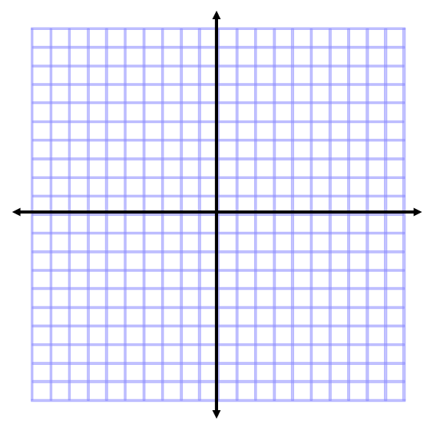
2. Find the Domain and Range.

a.) b.)

Domain: __________________________ Domain: __________________________

Range: ___________________________ Range: ___________________________

3. Consider the relation: The distance you are from the band and how loud it sounds to you.

a.) Identify the Independent Variable: ____________________________

Identify the Dependent Variable: _____________________________

b.) Sketch a reasonable graph AND label the axes appropriately.

4. Answer yes or no if each of the following is a function.

a.) {(-2, 4) (-1, 1) (1, 1) (2, 4)} function?__________

b.) {(4, -2) (1, -1) (1, 1) (4, 2)} function?__________

c.) {(a, b) (a, c) (b, a) (c, b)} function?__________

5. Answer yes or no if each of the following is a function.

a.) b.) c.)

function?__________ function?__________ function?__________

6. Use the functions below to complete the ordered pair.
Let: $f\left(x\right)=2x^{2}-6$
$g\left(x\right)=5-x$
$h\left(x\right)=|-6x+2|$

a.) $f(3)$ b.) $h(-12)$ 6a. _______________

6b. ______________

c.) $g(-9)$ d.) $g(3-b)$ 6c. _______________

6d. _______________

7. Graph each equation by first finding the x and y intercepts.
a.) -6x + 3y = 12 x-int = (____, ___) b.) 2x + 4y = 16 x-int = (____, ___)
y-int = ( ___, ____) y-int = ( ___, ____)
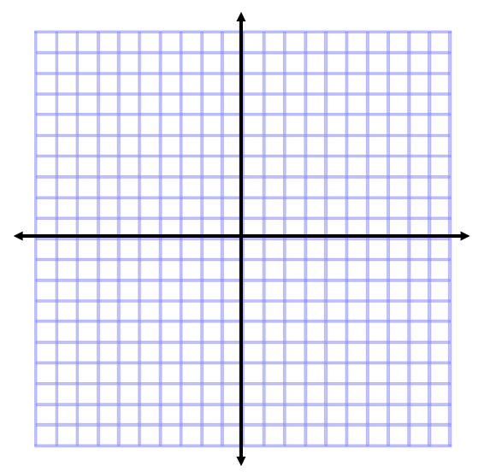

8. Find the slope in each situation.

a.) $2x=10$ b.) $-3x+6y=13$ 8a. ______________

8b. _______________

c.) The line containing the points d.) $-2y=20$ 8c. _______________
(3, -4) and (6, 8)
8d. _______________

- A line with the y-intercept = 1 and x-intercept = $-4$ 8e. _______________

9. Graph each equation. Show all of your work (show me your substitution (or) y-intercept and slope).

a.) $-3x+6y=24$ b.) $y=\frac{-2}{3}x+5$

10. Find an equation in slope/intercept form or standard form of the line that passes through
(-2, 6) and (0, 3).

10. ______________________________

11. Find an equation in slope/intercept form or standard form of the line containing point P (-2, 5) and having slope m = $\frac{-3}{4}$

11. _____________________________
12. Consider the line: $-2x – 7y = 28.$

a.) What is the slope of a line that is parallel to the given line? 12a. ________________

b.) What is the slope of a line that is perpendicular to the given line? 12b. ________________

13. Find equations in slope/intercept form or standard form of the lines go through point $P(0, -5)$ and that are parallel and perpendicular to line L
L: $y=\frac{3}{4}x+2$
Parallel: Perpendicular:

14. Graph the solution to each inequality.

a.) $6x+18y > 36$ b.) $3x-4y≥0$

15. Find the domain and range for each of the following

a.) $f\left(x\right)=x^{2}+3$ 15a. Domain: _____________________

Range: _______________________

b.) $f\left(x\right)=|x-4|$ 15b. Domain: ______________________

Range: _______________________

$c.) f\left(x\right)=\sqrt{x+2}-6$ 15c. Domain: ______________________

Range: _______________________

