Name: ___________________________________

Algebra II

Unit 2: Linear Functions

Priority Standards: A.CED.2: Create equations in two or more variables to represent relationships between quantities.

Unit “I can” statements:
- I can identify the domain and range, and the dependent and independent variables in a relation.

- I can identify functions and correctly interpret function notation.

- I can find the slope of a line and graph a line when given the slope and a point.

- I can rewrite equations into slope/intercept form and graph them by using the slope and y-intercept.

- I can find an equation of a line given its slope and y-intercept, its slope and a point, or two points.

- I can graph a linear inequality in two variables.

- I can describe how a simple quadratic, absolute value, or square root function is transformed by minor changes to the parent equation.

Common Core State Standards that are addressed in this unit include: F.IF.1a, F.IF.2a, F.IF.4, F.IF.5, F.IF.7b, F.IF.7c, A.CED.2a, A.CED.2, A.CED.3a, A.SSE.1a
For more information see www.corestandards.org/Math/

Relations

In this unit, our main focus is going to be on linear functions, and since this will involve graphing, we will have a quick review of the Cartesian Coordinate System.

Parts of the Cartesian Coordinate System  Points are graphed as ordered pairs. (x, y) | Graph the following points on the same coordinate plane: (2, 6) (3, 0) (-2, 3) (4, -5) (0, -4)  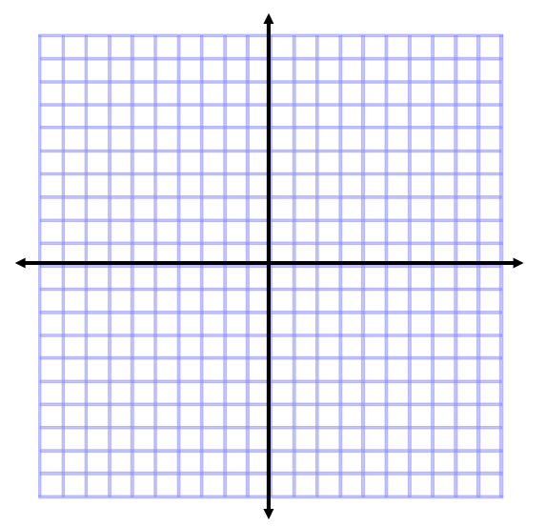

There are several important definitions that you need to know as we begin this unit.

Relation: ____________________________________________________________________________

Domain: _____________________________________________________________________________

Range: _______________________________________________________________________________

Break for Practice: Try to determine the domain and range for the following relations.

1.  Domain:  Range:  Domain:  Range:  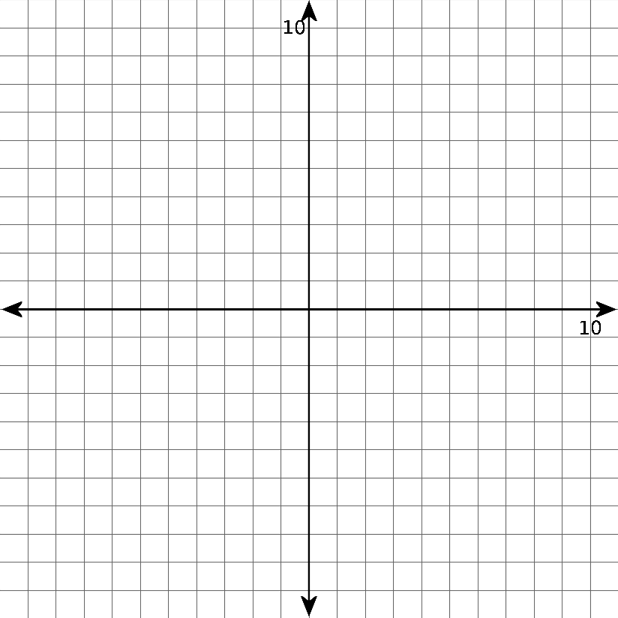 | 2.
3. | 4.  Domain:  Range:  Domain:  Range:
5. | 6.
Domain:

Range:
Domain:

Range:

Another skill we need to begin developing is that of Identifying the independent and dependent variables.

Break for Practice: For each problem: 1. Identify the independent and dependent variables.
2. Label the axes.
3. Sketch a reasonable graph.

- The height of a person is related to their age.

- The time it takes to get home is related to the speed you drive.

- A roast is taken from a refrigerator and put in an oven. The time spent in the oven is related to the temperature of the roast.

Extended Practice: Try to determine the domain and range for the following relations.

1.  Domain:  Range: | 2.  Domain:  Range:
3.  Domain:  Range: | 4.  Domain:  Range:
5.  Domain:  Range: | 6.  Domain:  Range:

Extended Practice Continued:
For each problem: a.) Identify the independent and dependent variables.
b.) Label the axes.
c.) Sketch a reasonable graph.

7. The number of used aluminum cans you collect and the number of dollars refunded to you are related.

8. The altitude of a punted football is related to the number of seconds since it was kicked.

9. The rate at which you are breathing is related to how long it has been since you finished running a race.

10. The price you pay for a carton of milk is related to how much milk the carton holds.

11. Calvin Butterball desires to lose some weight, so he reduces his food intake from 8000 calories per day to 2000 calories per day. His weight is related to the number of days that have elapsed since he reduced his food intake.

Beginning Functions

Throughout the year you will be investigating many special families of functions, but first you need to understand what a function is.

Review: Relation: any set of ordered pairs

New: Function: ___________________________________________________________________________

___________________________________________________________________________

Break for Practice: Which of the following are functions:

- {(1, 5), (2, 6), (3, 7)} __________ 2. {(1, 2), (2, 2), (3, 2)} __________

3. {(1, 1), (1, 2), (1, 3)} __________ 4. {(2, -2), (2, 2), (3, -3), (3, 3)} __________

- {(-2, 2), (2, 2), (-3, 3), (3, 3)} __________

It is also possible to identify a function from a graph. Sketch a graph for each of the above relations.

If a vertical line passes through the graphs, what do you notice?

1. | 2. | 3.
4. | 5.
Vertical Line Test: If a vertical line can_____________________________________________________

_______________________________________________________________________________________

Break for Practice: Decide whether or not each of the following graphs represent functions.

1. | 2. | 3.
4. | 5. | 6.

Extended Practice: Tell whether or not the relation is a function.

1. {(1, 3), (5, 6), (6, 6)} | 2. {(1, 4), (2, 4), (3, 4)}
3. {(-1, -2), (0, 0), (1, 2)} | 4. {(1, a), (2, b), (3, c)}
5. {(1, a), (2, a), (3, a)} | 6. {(a, b), (b, c), (c, d)}
7. {(0, 0), (1, 1), (1, -1), (2, 4), (2, -4)} | 8. {(0, 0), (1, 1), (-1, 1), (2, 4), (-2, 4)}
Extended Practice continued: Decide whether or not each of the following graphs represents a function.

9. | 10. | 11.
12. | 13. | 14.
15. | 16. | 17.

Function Notation

Now that you know what a function is, you also need to know another way to write functions. This method is called function notation.

Consider the relation $y=3x+1$. Since every x-value that you put in would generate a unique y-value, this relation is a function. Since it is a function, it can be written in function notation which looks like this: $f\left(x\right)=3x+1.$ $f(x)$ is just another way of writing y. Letters other than f can also be used, and this allows us to give different functions different names.

Break for Practice: Let $f\left(x\right)=3x-2 g\left(x\right)=x^{2} and h\left(x\right)=\left|x\right|-2$
Calculate the following.

- $f(3)$ 2. $g(2)$ 3. $h(-1)$

- $f\left(-4\right)$ 5. $g\left(3a\right)$ 6. $f\left(a+2\right)$

Extended Practice: Let $f\left(x\right)=2x-5 g\left(x\right)=7-3x and h\left(x\right)=4-3x+x^{2}.$
Evaluate the following.

1.$f\left(4\right)$ | 2. $g\left(-3\right)$ | 3.$h\left(2\right)$
4.$f\left(-5\right)$ | 5.$g\left(\frac{4}{3}\right)$ | 6. $h\left(-5\right)$
7.$h\left(0\right)$ | 8.$g\left(-5\right)$ | 9. $f\left(a\right)$
10.$h\left(r\right)$ | 11.$g\left(m\right)$ | 12. $f\left(a+b\right)$
13. Coming off an embarrassing loss to the tortoise, the hare wanted a rematch. The tortoise, being a wise old animal, agreed to race again if he was given a 30-minute lead. Both start at the same point. The Tortoise races at a constant speed of 50 feet per minute, and the hare races at a constant speed of 160 feet per minute.
Let x = number of minutes since the tortoise started, T(x) = number of feet the tortoise has gone, and H(x) = number of feet the hare has gone.

- Write equations expressing T(x) and H(x) in terms of x.

- Find T(35) and H(35). Who is ahead at the end of 35 minutes?

Graphs of Linear Equations in Two Variables

Now that you know a bit about relations and functions, let’s look at graphing equations that have two variables.

Graph the equation: $2x-3y=12$

Method: Solve for y and find at least 4 points to graph. Choose “nice” x-values.
X | Y

Result: The graph of any equation of the form $Ax+By=C$ is a ____________________. These equations

are called _______________________________ equations. Note: Only two points are needed to graph these

equations, and often these points are the x-intercept and the y-intercept.

Break for Practice: Identify each equation as linear or not linear. Graph the linear equations.

1. $3x+4y=12$ 2. $3x+2y-9=0$

3. $2x^{2}+y=3$ 4. $-2x+y=6$

5. $x=4$ 6. $y=-3$

Extended Practice: Identify as linear or not linear. Graph the linear equations.

1. $x+2y=4$ | 2. $3x-2y+18=0$
3. $x-3y=0$ | 4. $2y-8=0$
5. $2x+5y=15$ | 6. $3x-2y=7$
Slope

What do you remember about slope? Look at the previous section for ideas.

Summary: Slope is a number that describes the _____________________ and __________________ of a line.

Slope, m = ________________

If an equation is in the form y = _____________________________, then m is the slope.

The slope between the two points $\left(x_{1}, y_{1}\right) and \left(x_{2}, y_{2}\right) is m=$

Break for Practice: Calculate the slope in each of the following

1.  $$m =$$ | 2.  $$m =$$ | 3.  $$m =$$

4. Calculate the slope between the two points given.

a.) (2, 3) and (5, -2) b.) (-5, 2) and (-5, 4)

5. Find the slope from each equation.

a.) $x+3y=9$ b.) $2x-7y=14$

6. Graph the line through P with a slope of m.

- P(-1, -2) m = 3 b.) P(3, -1) m = $\frac{-3}{2}$

Extended Practice: Find the slope of the line containing the given points.

1. (3, 1) and (5, 5) | 2. (3, -4) and (3, -2)
3. (4, -1) and (-2, 3) | 4. (-5, -2) and (5, -2)

Extended Practice Continued: Find the slope of each line.

5. $x-y+1=0$ | 6. $2x+4y=5$
7. $4x-3y=3$ | 8. $3x-3y=5$
9. $4y-5=6x$ | 10. $x=3y+2$

Extended Practice Continued: Graph the line through point P having slope m.

11. P(-2, -1) m = 3 | 12. P(2, -3) m = $-\frac{1}{2}$ | 13. P(-1, -4) m = $\frac{5}{3}$

Graphing Equations using Slope/Intercept Form

Consider $y=\frac{2}{3}x-4$

Graph it.

What is the value of the slope? __________

Where do you see the slope in the given equation?

Calculate the y-intercept. Remember that this is the value

of y when x = 0. __________

Where do you see the y-intercept in the given equation?

Summary:

Break for Practice: Graph each of the following by first identifying m and b.

1. $y=-\frac{1}{4}x+6$ | 2. $y=4x-2$
3. $y=x$ | 4. $3x+4y=12$
5. $-2x+4y=8$ | Summary:  A positive slope looks like  A negative slope looks like  No slope looks like  A slope of zero looks like
Extended Practice: Identify the slope, m and y-intercept, b of each equation, and graph.

1. $y=\frac{3}{4}x+2$ | 2. $y=-\frac{1}{3}x+4$
3. $y=6$ | 4. $2x-3y=6$
5. $3x+4y=-12$ | 6. $5x+3y=6$
Finding an Equation of a Line

Now that you know several ways to graph linear equations, the next thing to learn is how to find an equation for a line when given key pieces of information. In order to do this, it helps to know three different forms for linear equations.

I. Slope-Intercept Form:

- A line has y-intercept b if it intersects the y-axis at the point $(0, b)$
- A line has x-intercept a if it intersects the y-axis at the point $(a, 0)$

I b is the y-intercept of a line, the equation _______________________ is called the slope-intercept form of the equation of the line.

x, y m b

II. Standard Form:

- $Ax+By=C$

x, y m b

III. Point-Slope Form:

- The line containing the point $(x_{1}, y_{1})$ and having slope m has the equation.

** Notice that we are working with only ONE point

Break for Practice: Depending on the information that you are given will help you to decide which form you want to start with.

Finding an Equation of a Line: $y=mx+b$

1. Given: slope and y-intercept
Example: Find an equation in slope-intercept form of the line having slope $-\frac{3}{4}$ and y-intercept 2.

2. Given: standard form
Example: Put $3x+4y=1$ into slope-intercept form

3. Given: a point and the slope
Example: Find an equation in slope-intercept form of the line containing the point (4, -3) and having slope
$-\frac{2}{5}$.

4. Given: two points
Example: Find an equation in slope-intercept form (2, -3) and (-1, 2).

5. Given: a graphed line

Finding an Equation of a Line: $Ax+By=C$

6. Given: slope and y-intercept
Example: Find an equation in standard form of the line having slope $-1$ and y-intercept 3.
Example: Find an equation in standard form of the line having slope $\frac{1}{2}$ and y-intercept$\frac{3}{2}$.

7. Given: a point and the slope
Example: Find an equation in standard form of the line containing the point (4, 1) and having slope
$-1 .$

Example: Find an equation in standard form of the line containing the point (3, -2) and having
slope$-\frac{3}{2}$.

8. Given: two points
Example: Find an equation in standard form (2, -3) and (-1, 2)

Example: Find an equation in standard form (-3, 2) and (4, 2)

Extended Practice: Find the equation in Slope-Intercept Form (odd#’s) and Standard Form (even #’s) for the line with the given information.

- m = -1 and b = 2 | - m = $\frac{1}{2}$ and b = $\frac{3}{2}$
- The line contains the point P(2, 3) and m = 1 | - The line contains the point P(2, 1) and m = $\frac{2}{3}$
- The line contains the point P(-2, -1) and m = 0 | - The line contains the points (3, -2) and (-2, 3)
- The line contains the points (4, -5) and (1, -4)

Look at the two parallel lines shown, and the two perpendicular lines shown. What is true about their slopes?

Parallel Lines have | Perpendicular Lines have

Break for Practice: Find equations in standard form of the lines through P that are
- parallel to L
- perpendicular to L

- P(2, -3) L: $2x+7y=14$

- P(-5, -1) L: $x-3y=6$

- Find an equation for a line with an x-intercept of 7 and parallel to the y-axis.

- Find an equation for a line with a y-intercept of -2 and perpendicular to the y-axis.

- Find an equation for a line with an x-intercept of 2 and a y-intercept of 4.

Extended Practice: Find equations in standard form of the lines through P that are
- parallel to L
- perpendicular to L

- P(0, 3) L: $x+y=5$

- P(-1, 2) L: $x-3y=-2$

Extended Practice Continued:

- Find an equation for the line having a y-intercept of 6 and parallel to the x-axis. | - Find an equation for the line having an x-intercept of -4 and parallel to the y-axis.
- Find an equation for the line having an x-intercept of -3 and a y-intercept of 3. | - Find an equation for the line passing through the points (1, 4) and (-3, 4).

Graphing Linear Inequalities

Now that you know how to graph linear equations, you can learn how to graph linear inequalities. In order to do this, you will want to use the following steps.

Steps:  1. Graph the boundary line.  Use a solid line if $≤or ≥$.  Use a dashed line if < or >  2. Test a point to determine  which side of the line to  shade. Shade the side that  gives a true inequality. | Example: $y<3x-2$
Break for Practice: Graph each inequality.

1. $3x+4y≥8$ 2. $-y+3≤0$

3. $x-5≤0$ 4. $4x-5y>15$

Extended Practice: Graph each inequality.

- $y-2≥0$ | - $2x-y≤2$
- $3x+2y<6$ | - $x<2y$
- $x+1≥0$ | - $y≤6$
Common Functions

This unit will end with the study of common functions. You will explore what the basic graph of each looks like, and how minor changes in the equation change the graph.

Quadratic: $y=x^{2}$

Graph the function by completing the table of values.

x | y
0
1
-1
2
-2

Describe the graph. What does it look like?

Domain: _______________ Range: _______________

What happens if … $h\left(x\right)={-x}^{2}$?  Write your predictions.  Graph the function.  Describe what changed.  Domain: _______________  Range: _______________ | What happens if … $g\left(x\right)={2x}^{2}$?  Write your predictions.  Graph the function.  Describe what changed.  Domain: _______________  Range: _______________
Absolute Value: $y=\left|x\right|$

Graph the function by completing the table of values.

x | y
0
1
-1
2
-2
3
-3

Describe the graph. What does it look like?

Domain: _______________ Range: _______________

What happens if … $h\left(x\right)=\left|x\right|+2$?  Write your predictions.  Graph the function.  Describe what changed.  Domain: _______________  Range: _______________ | What happens if … $g\left(x\right)=\left|x-4\right|$?  Write your predictions.  Graph the function.  Describe what changed.  Domain: _______________  Range: _______________

Square Root: $y=\sqrt{x}$

Graph the function by completing the table of values.

x | y
0
1
2
3
4

Describe the graph. What does it look like?

Domain: _______________ Range: _______________

What happens if … $h\left(x\right)=\sqrt{x-3}$?  Write your predictions.  Graph the function.  Describe what changed.  Domain: _______________  Range: _______________ | What happens if … $g\left(x\right)=\sqrt{x}-3$?  Write your predictions.  Graph the function.  Describe what changed.  Domain: _______________  Range: _______________

Summary:

Original Graphs:

What happens when…

1. A number is added or subtracted OUTSIDE of the main function operation, the graph will

Examples:

What will happen to the Domain of $f\left(x\right)=x^{2}$ _______________ & Range $f\left(x\right)=x^{2}$ _______________

$f\left(x\right)=\left|x\right|$ _______________ & Range $f\left(x\right)=\left|x\right|$ _______________

$f(x)=\sqrt{x}$ _______________ & Range $f(x)=\sqrt{x}$ _______________

2. A number is added or subtracted INSIDE of the main function operation, the graph will

Examples:

What will happen to the Domain of $f\left(x\right)=x^{2}$ _______________ & Range $f\left(x\right)=x^{2}$ _______________

$f\left(x\right)=\left|x\right|$ _______________ & Range $f\left(x\right)=\left|x\right|$ _______________

$f(x)=\sqrt{x}$ _______________ & Range $f(x)=\sqrt{x}$ _______________

3. A number multiplies the main function operation, the graph will

Examples:

What will happen to the Domain of $f\left(x\right)=x^{2}$ _______________ & Range $f\left(x\right)=x^{2}$ _______________

$f\left(x\right)=\left|x\right|$ _______________ & Range $f\left(x\right)=\left|x\right|$ _______________

$f(x)=\sqrt{x}$ _______________ & Range $f(x)=\sqrt{x}$ _______________
Extended Practice: Find the domain and range for each of the following functions.
1. $f\left(x\right)=\sqrt{x+2}$
Domain: _______________

Range: ________________

2. $g\left(x\right)=\left|x\right|-5$
Domain: _______________

Range: ________________

3. $h\left(x\right)=x^{2}+4$
Domain: _______________

Range: ________________

4. $f\left(x\right)=\left|x+3\right|-6$
Domain: _______________

Range: ________________

5. $h\left(x\right)=-\sqrt{x}$
Domain: _______________

Range: ________________

6. $g\left(x\right)=-2∙\left|x\right|+3$
Domain: _______________

Range: ________________

7. $f\left(x\right)=\frac{1}{2}{(x-7)}^{2}$
Domain: _______________

Range: ________________

