1. a.) Find the coordinates of the midpoint of a segment connecting the points (-2, 9) and (8, 11).

b.) Find the coordinates of the midpoint of a segment connecting the endpoints A(-4, 7) and B(-10, -1).

c.) Determine the distance from the point (10, 1) to the point (-3, 2). Round answers to two decimal places.

d.) Determine the distance from the point (8, 1) to the point (-3, 0). Round answers to two decimal places.

2. Identify the pattern, then find the next number in the pattern.

2a.) 1, 5, 9, 13, ________ 2a.) Pattern: ________________________________________

2b.) 1, 3, 6, 10, 15, ________ 2b.) Pattern: ________________________________________

2c.) $\frac{1}{1}$, $\frac{3}{2}, \frac{5}{3}, \frac{7}{4},$________ 2c.) Pattern: ________________________________________

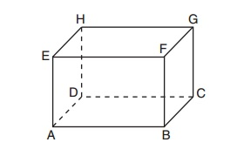

3. Use the diagram at the right to answer 3a-3d.

a.) Name 2 points that are collinear: __________________________

b.) Name 3 points that are coplanar: __________________________

c.) Name two lines that intersect at point D: __________________________

d.) Name two planes that intersect at line EF: _______ ___________________

4. a.) If two lines intersect, then their intersection is exactly __________________.

b.) If two planes intersect, then their intersection is a ______________.

5. a.) The sum of the measures of two complimentary angles is ____________.

b.) The sum of the measures of two supplementary angles is ____________.

c.) Two angles that form a linear pair, their measures add up to __________.

d.) Vertical angles measures are _____________ to each other.

6. a.) A polygon with all sides congruent is called _________________________.

b.) A polygon with all interior angles congruent is called ________________________.

c.) A polygon with all sides and angles congruent is called _______________________.

7. Give the number of sides for each polygon.

a.) Octagon: ________ b.) Quadrilateral: ________ c.) Decagon: ________

d.) Hexagon:________ e.) Triangle:________ f.) Nonagon:________

g.) Pentagon:________ h.) Heptagon:________

8. Draw an example of:

a.) a concave polygon. b.) a convex polygon.

9. Area formula of a:

a.) Triangle: A=_____________ b.) Rectangle: A=_____________

c.) Square: A=_____________ d.) Circle: A=_____________

10. a.) Perimeter of a Rectangle: P=______________ b.) Circumference of a Circle: C= ________

11. Properties (*Reflexive, Symmetric or Transitive*) are being shown in the following statements. Complete the

statement so that it is true.

a.) Reflexive: $\overline{RT}≅$

__________

b.) Symmetric: If $m∠$ ABC $≅ m∠$ RST, then $≅$__________ __________.

c.) Transitive: If $m∠1≅ m∠2$, and $m∠$ 23, then __________ ___________.

12. In the diagram below, if $NO = 8 cm$ and , find $OP$.

N

O

P

12.) OP = ____________

13. In the diagram below, $RT = 17 in$. Find *RS* and *ST*.

13.) RS = ____________

S

T

R

ST = ____________

14. Given point E is the midpoint of , determine *EQ* with the given information.

$$6x-13$$

$$3x+11$$

E

Q

V

14.) EQ = ____________

15. Classify each polygon by number of sides and determine whether it is equiangular, equilateral, or regular.

a.) b.)

__________________, __________________ __________________, __________________

16. Use the information about the figure to find the indicated measures. LABEL your answers!

a.) Rectangle:

*2 in*.

*x*

Perimeter= 14 inches 16a.) *x* = _____________

Find *x* and area.

Area = _______________

*x*

b.) Square:

Area= 56.25 $m^{2}$ 16b.) *x* = _____________

Find *x* and the perimeter.

Perimeter = ____________

c.) Triangle:

*h=14 cm*

*x*

Area= 56 $cm^{2}$ 16c.) *x* = _____________

Find x.

17. Use the diagram to identify an example of: *corresponding, alternate interior, alternate exterior, consecutive interior or vertical angles.*

*n*

*m*

2

4

3

5

6

8

7

1

a.) Corresponding Angles: ___________________________

b.) Alternate Interior Angles: ________________________

c.) Consecutive Interior Angles: _____________________

*k*

d.) Alternate Exterior Angles: _______________________

e.) Vertical Angles: _______________________________

f.) Linear Pair: __________________________________

18. In the diagram above- If $m∥n$ and *k* is a transversal then…

a.) Corresponding angles are ___________________________

b.) Consecutive interior angles are ___________________________

c.) Alternate exterior angles are ___________________________

d.) Alternate interior angles are ___________________________

19. Determine the value of *x*, if $J∥K$.

a.)

$$(7x-80)°$$

$$2x°$$

$$J$$

$$K$$

19a.)

$$(4x-12)°$$



$$(2x+48)°$$



$$J$$



$$K$$

 ________________

b.)

19b.) ________________

c.) 19c.) ______________

d.) 19d.) ______________

20. Use the following conditional statement to answer questions a-f.

*If an angles measure is 90°, then it is a right angle.*

a.) What is the hypothesis? ______________________________________________________________

b.) What is the conclusion?_______________________________________________________________

c.) Write the converse. __________________________________________________________________

d.) Write the inverse. ___________________________________________________________________

e.) Write the contrapositive. ______________________________________________________________

f.) Write as a biconditional statement.

___________________________________________________________________________________

21. Show your work!Find the value of the variables and the measure of each angle.



a.) b.)

$$(3x+24)°$$

$(5x-30)$ °

28˚

*y˚*

21a.) *x* =_________ 21b.) *x* =_________

*y* = *_________ y* = *_________*

c.) Find the measures of *x* and *y*.

21c.) *x*=__________

°

()°

(

*y*=__________

22. Use the diagram and information below to determine if $a∥b$. Write parallel or not parallel on the line provided. If the lines are parallel, write which **theorem or postulate** justifies your answer.

1 2 3 4

5 6 7 8

b

a

a.) Given: $∠$ 5 $≅ ∠2$ 22a.) _________________________

theorem or postulate - ____________________________

b.) Given: $m∠$ 2 + $m∠$ 3= 180˚ 22b.)_________________________

theorem or postulate - ____________________________

c.) Given: $∠$ 5 $≅ ∠4$ 22c.)_________________________

theorem or postulate - ____________________________

d.) Given: $∠$ 2 $≅ ∠7$ 22d.)_________________________

theorem or postulate - ____________________________

e.) Given: $m∠$ 2 + $m∠$ 6= 180˚ 22e.)_________________________

theorem or postulate - ____________________________

23. Is writing a proof an example of (circle one) **inductive** or **deductive** reasoning. Explain your answer.

________________________________________________________________________________

________________________________________________________________________________

_________________________________________________________________________________

24. Decide whether the statement is true or false. If false, provide a counterexample.

a.) $x²$ is always larger than *x*. b.) The product of two negative numbers is always positive.

25. Use the Law of Syllogism to write a new conditional statement based on the following:

If Ellie goes to college, then she will major in Chemistry. If Ellie majors in Chemistry, the she will need to

buy a lab manual.

26. In the following statement, what type of reasoning was used (circle one) **inductive** or **deductive**. Explain your reasoning.

For the past 5 years, your neighbor went on vacation for the 4th of July and they ask you to feed their dog. You conclude you will be asked to feed their dog the next 4th of July.

27. Determine the measure of *t*.

27.) ___________

t

75˚

98˚

28. Determine the value of *x*.

28.) ___________

*x*

(2x + 10)°



29. Find *x* and *y*.

55˚

$$(2x + 25)°$$

*y˚*

a.) b.) 29a.) *x=*

$$9 cm$$



$$9 cm$$



$$9 cm$$



$(4x -12)°$____________

25

*y˚*

y*=*____________

29b.) *x=*____________

y*=*____________

c.) 29c.) *x=*____________

144°

) yd

yd

y*=*_____________

30. State the third congruence that must be given to prove that  using the indicated postulate.

a.) , $∠C≅∠F$, ______ ______ b.) , , ____________

**Use the SAS Congruence Theorem**  **Use the AAS Congruence Postulate**



c.) $∠A≅∠D$, , ____ _____ d.) $△ABC$ and $△DEF$ are right triangles,

 **Use the ASA Congruence Postulate $\overline{BC}≅\overline{EF}$** , $__________≅__________$

**Use the HL Congruence Postulate**

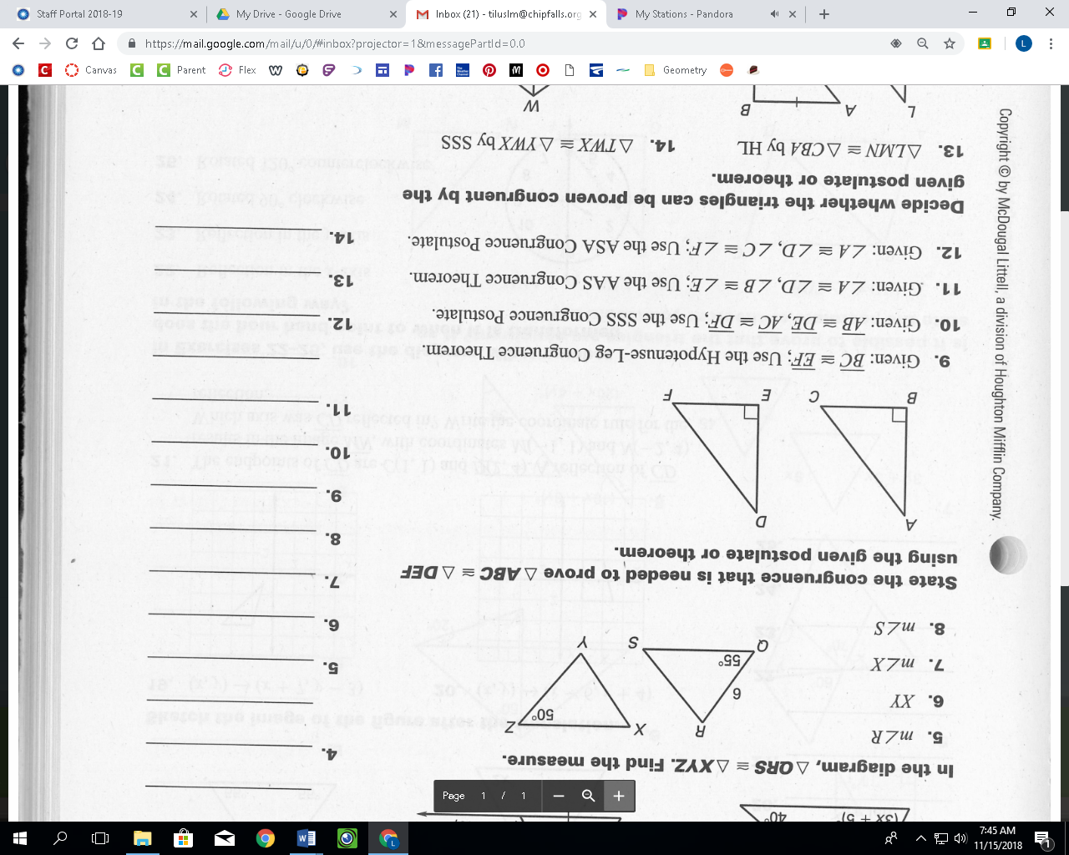

31. Which postulate or theorem proves that each pair of triangles below is congruent?

a.) b.) c.)

31a.)_______________ 31b.)_______________ 31c.)_______________

d.) e.)

31d.)_______________ 31e.)_______________

32. Fill in the blanks to complete the proof.

A

B

C

D

**Given:**  bisects  and 

**Prove:** 

Statement Reason

1. _______________________________________ 1. ____________________________________

2. _______________________________________ 2. ____________________________________

3. _______________________________________ 3. ____________________________________

4. ______________________________________ 4. ____________________________________

5. ______________________________________ 5. ____________________________________

____________________________________

33. Fill in the blanks to complete the proof.

V

S

R

U

T

**Given: $\overline{RS} || \overline{UV}$**  and $\overline{RS}≅\overline{UV}$

**Prove: $\overline{RT}≅\overline{VT}$**

Statement Reason

1. _______________________________________ 1. ____________________________________

2. _______________________________________ 2. ____________________________________

3. _______________________________________ 3. ____________________________________

4. ______________________________________ 4. ____________________________________

5. ______________________________________ 5. ____________________________________

6. ______________________________________ 6. ____________________________________

34. Fill in the blanks to complete the proof. 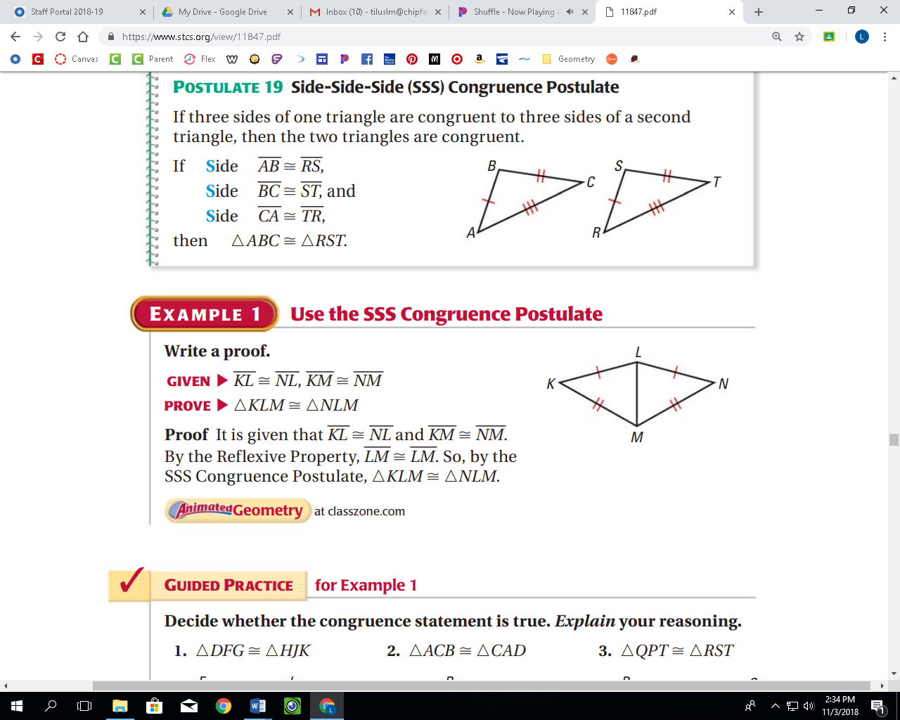

**Given:**

**Prove:**

Statement Reason

1. ________________________________________ 1. ____________________________________

2. _______________________________________ 2. ____________________________________

3. _______________________________________ 3. ____________________________________

4. _______________________________________ 4. ____________________________________

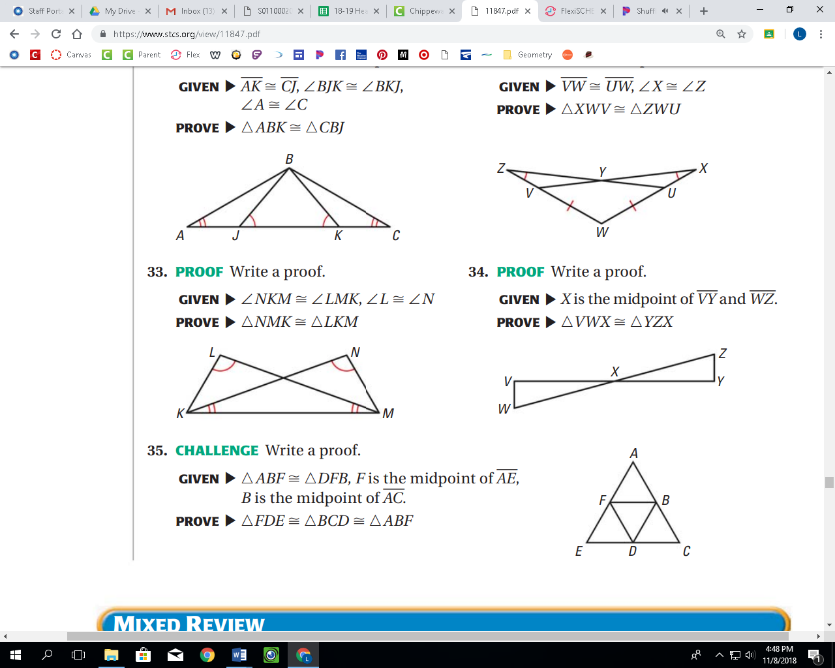35. Fill in the blanks to complete the proof.

**Given:**

**Prove:**

Statement Reason

1. _______________________________________ 1. ____________________________________

2. _______________________________________ 2. ____________________________________

3. _______________________________________ 3. ____________________________________

4. ______________________________________ 4. ____________________________________

5. ______________________________________ 5. ____________________________________



36. Fill in the blanks to complete the proof.

**Given:**  ,

**Prove:**

Statement Reason

1. _______________________________________ 1. ____________________________________

2. _______________________________________ 2. ____________________________________

3. _______________________________________ 3. ____________________________________

4. ______________________________________ 4. ____________________________________

5. ______________________________________ 5. ____________________________________

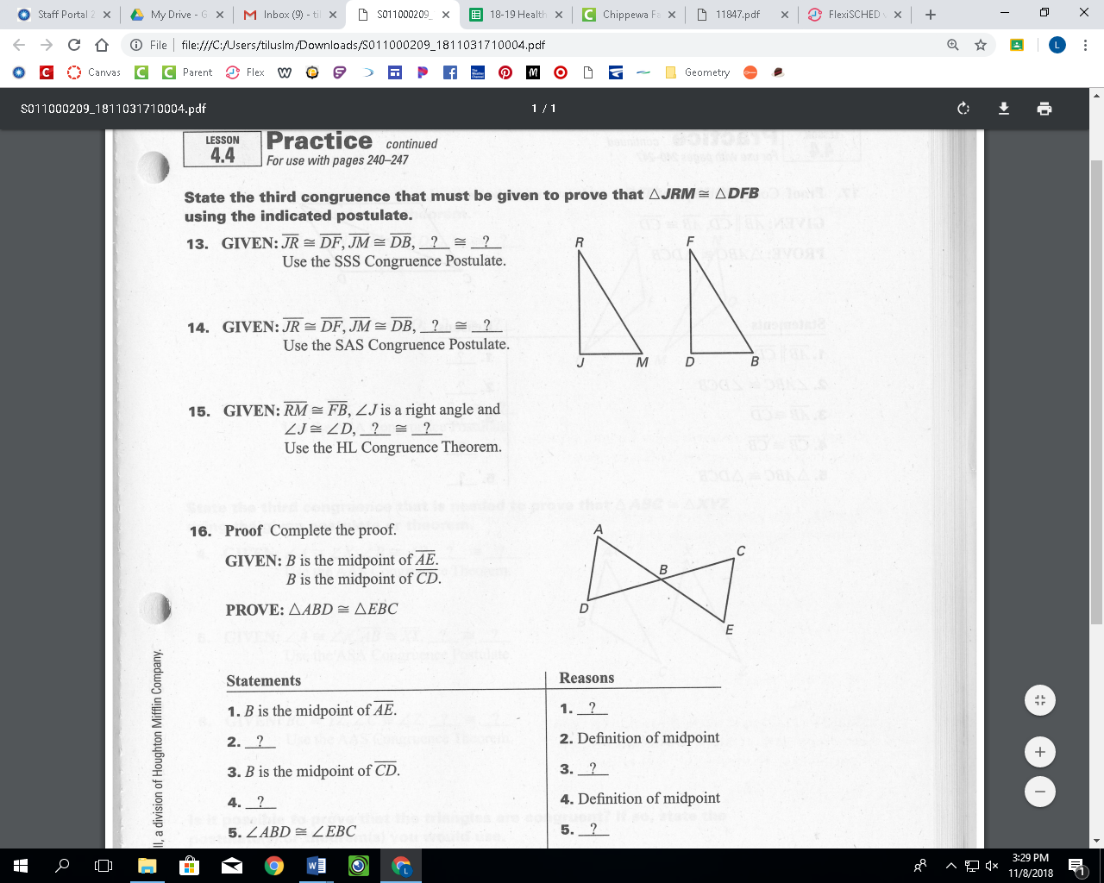

37. Fill in the blanks to complete the proof.

**Given:**  *B* is the midpoint of $\overline{AE}$

*B* is the midpoint of $\overline{CD}$

**Prove: $△ABD≅△EBC$**

Statement Reason

1. _______________________________________ 1. Given

2. _______________________________________ 2. ____________________________________

3. _______________________________________ 2. Given

4. _______________________________________ 4. ____________________________________

5. ______________________________________ 5. ____________________________________

6. ______________________________________ 6. ____________________________________

38. Find the value of *x*.

X

P

Y

N

$$6x-9$$

$$x+21$$

S

Q

R

T

(5x - 36)˚

(2x + 21)˚

a.) b.)

38a.) ___________________ 38b.) ___________________

39. Use the figure below to answer the questions.

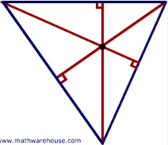

**G**

**I**

**H**

**J**

**K**

**L**

**P**

a.) $\overline{GL}$, $\overline{HJ}$, $\overline{IK}$, are called_________________________

b.) What is point P called? _______________________

40. Use the figure below to answer the questions.

**A**

**C**

**B**

**D**

**E**

**F**

**P**

**11 in**

a.) $\overline{DP}$, $\overline{EP}$, $\overline{FP}$ are called _______________________

b.) What is point P called? ______________________

**10 in**

c.) $CP =$ d.) $AD=$

**8 in**

**5 in**

e.) f.).

41. Use the figure below to answer the questions.

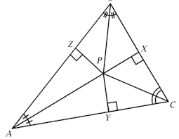

*B*

a.) $\overline{AP}$, $\overline{BP}$, $\overline{CP}$, are called

$$6x$$

__________________________

b.) What is point P called?

$$x+5$$

 _________________________

c.) Find the value of *x*.

$$3x-7$$

28.) Solve the proportion.

42. In the diagram below, $LS = 36 cm$, $TP=20 cm$, $KP=15 cm$ and $JR=25 cm$.

S

T

R

P

K

L

J

a.) $\overline{SL}$, $\overline{TJ}$, $\overline{RK}$ are called _______________________

b.) What is Point P called? ___________________________

c.) $PL=$ d.) $PS=$

e.) f.)

g.) h.)

i.) j.)

43. Is it possible to construct a triangle with the given side lengths? If not, explain why.

a.) 12, 14, 25 b.) 4, 9, 13 c.) 12, 13, 20

44. Describe the possible lengths of the third side of the triangle given the lengths of the other two sides.

a.) 16 inches, 23 inches b.) 18 feet, 5 yards

45. Complete with $<, >or=.$ Justify your answer.

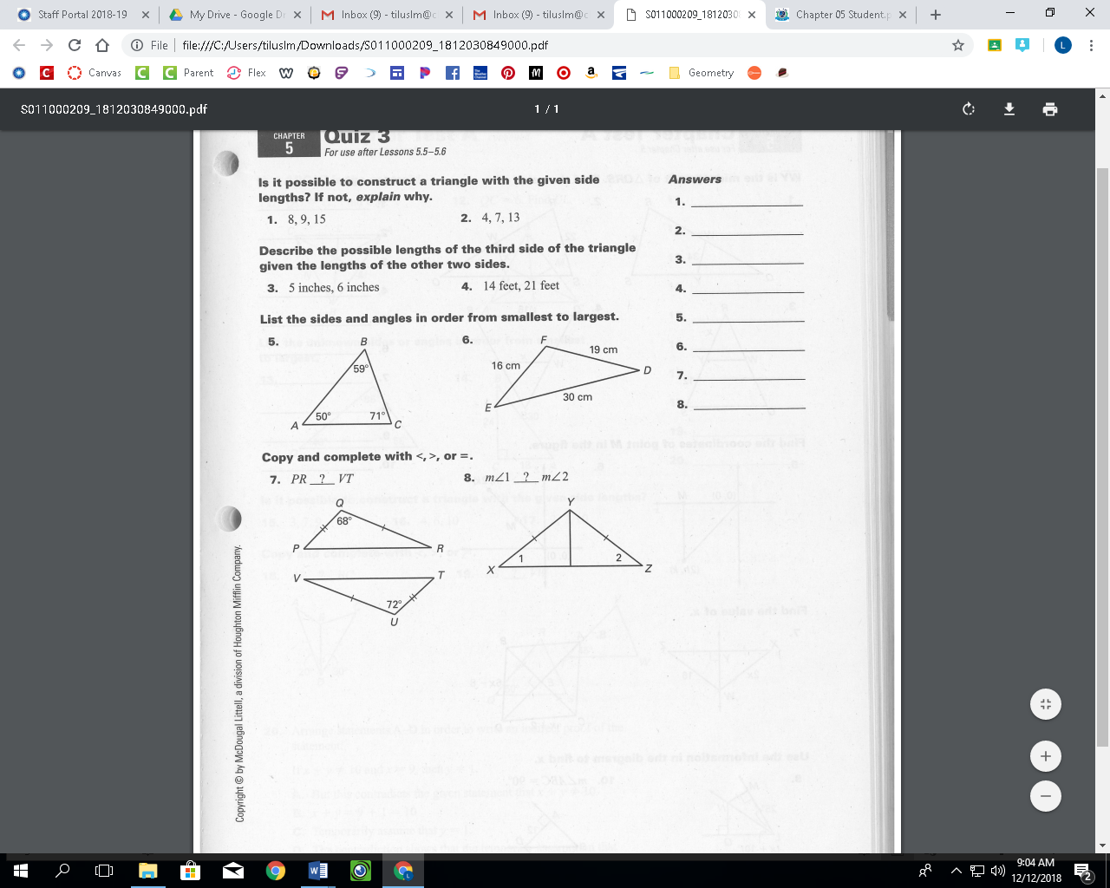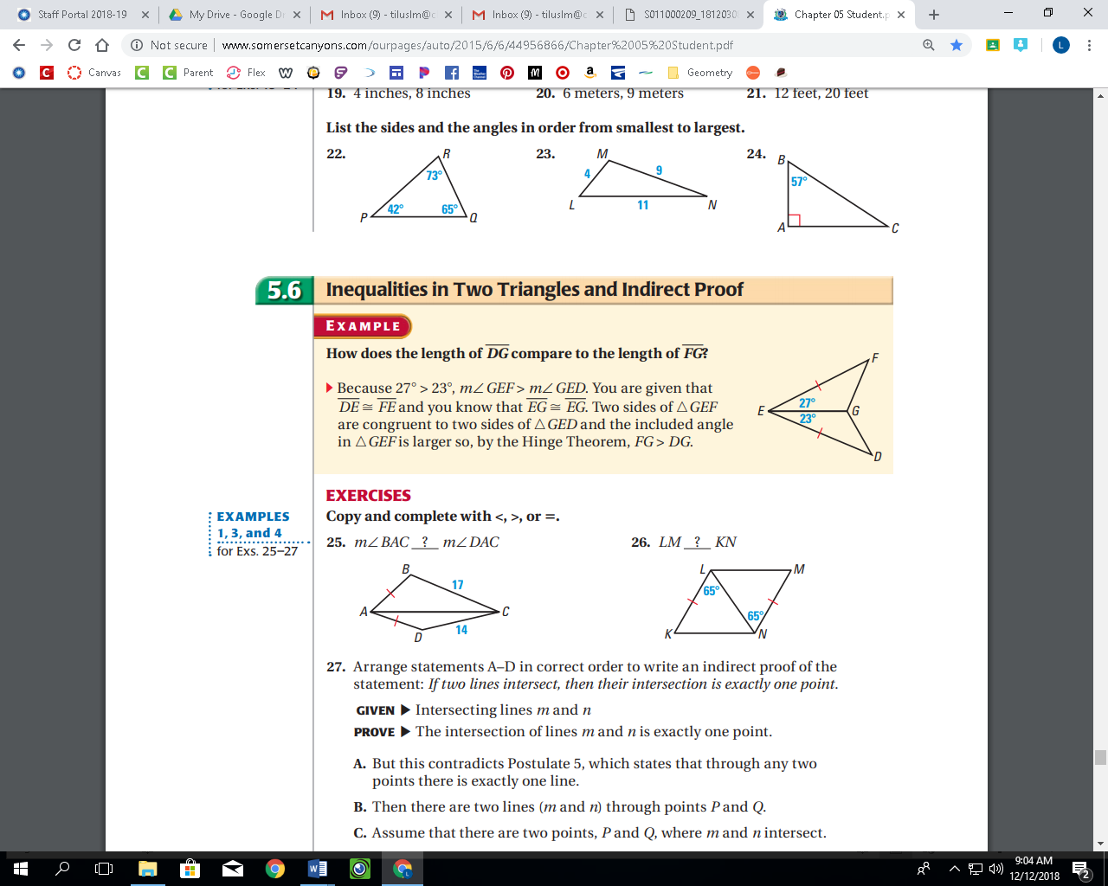

54. 55. 56.

46. Solve the proportions.

a.)  b.)  c.)

47. Find the value of *x*.

*x*

a) b)

C

A

B

V

48. If ABCDE ~ PQRST, find the scale factor of ABCDE to ABCDE and the missing values *x*, *y*, and *z*.

A 20 B T 4 P

143˚

*x* C 8

5

z˚

E D S  Q

*y*

R

49. Determine if the two triangles are similar. If yes, write a similarity statement and the theorem that proves they are similar. If no, say not similar. **Show proof.**

A

B

C

X

Y

Z

36

24

15

12

113˚

113˚

8

5

a.)

If **YES**: Similarity statement:___________________________ Theorem:__________________

b.)

R

16

T

12

6

S

D

E

4

F

3

2

If **YES**: Similarity statement:___________________________

Theorem:___________________

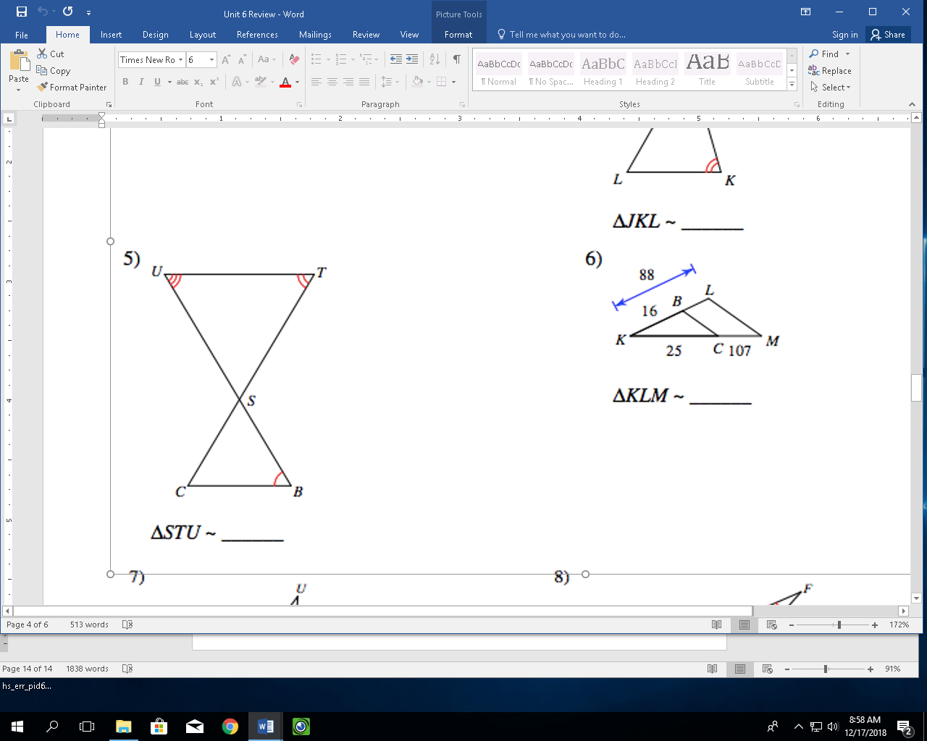

c.)

If **YES**: Similarity statement:___________________________

Theorem:___________________

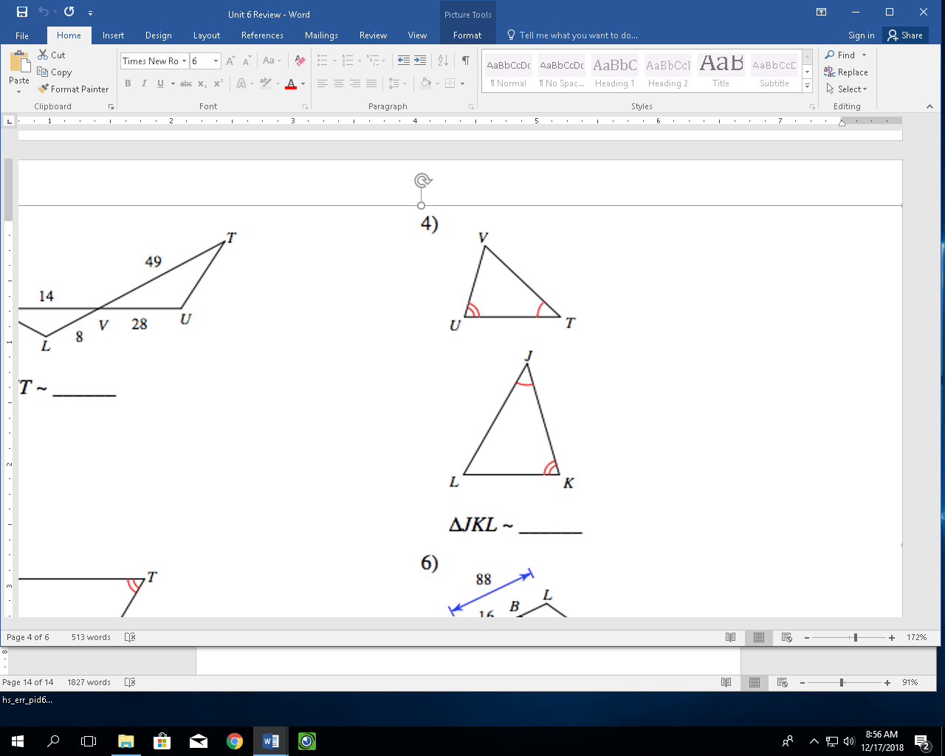

d.)

If **YES**: Similarity statement:___________________________

Theorem:___________________

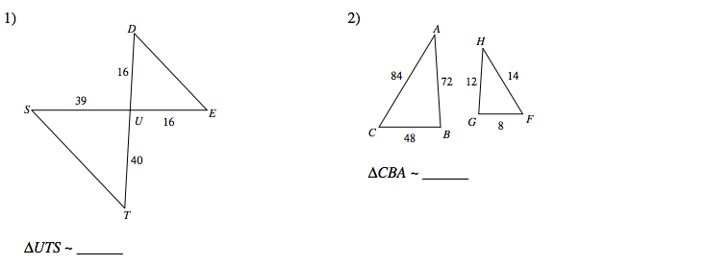 e.)

If **YES**: Similarity statement:___________________________

Theorem:___________________