Name: ________________________________________

Geometry
Mrs. Tilus

Unit 10: Properties of Circles

Priority Standard: : G-C 1-5: Understand and apply theorems about circles. Find arc lengths and areas of sectors of circles.

Unit 10 “I can” Statements:
- I can use the properties of a tangent to a circle.
- I can use angle measures to find arc measures.
- I can use relationships of arcs and chords in a circle.
- I can use inscribed angles of circles.
- I can find the measures of angles inside or outside a circle.
- I can find segment lengths in circles.
- I can use write equations of circles in the coordinate plane.

Chapter 10.1: Use Properties of Tangents

A circle is the set of all points in a plane that are _______________________
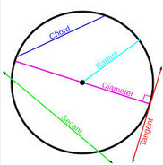
from a given point called the _________________ of the circle.

A segment whose endpoints are the center and any point on the
circle is a _____________________ .

A __________________ is a segment whose endpoints are on a circle.

A __________________ is a chord that contains the center of the circle.

A __________________ is a line that intersects a circle in two points.

A __________________ is a line in the plane of a circle that intersect the circle in exactly one point, called the
__________________________________ .

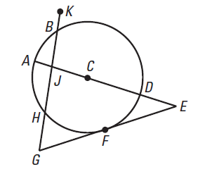
Example #1: Tell whether the line or segment is best described as a chord, a secant, a tangent, a diameter, or a radius of $⨀C$.

a. $\overline{AD}$

b. $\overline{CD}$

c. $\overset{⃡}{EG}$

d. $\overline{HB}$
G
e. $\overset{⃡}{GK}$

In a plane, two circles can intersect in _____________________ points, ______________________ point or

______________________ points.
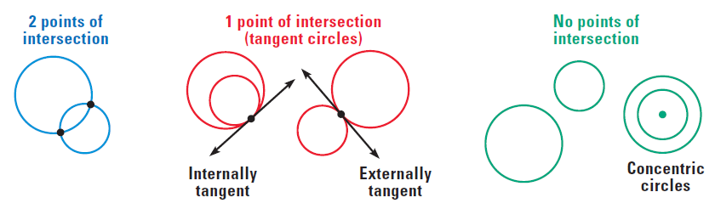

Coplanar circles that intersect in one point are called __________________________________.

Coplanar circles that have a common center are called __________________________________.

A line, ray or segment that is tangent to two coplanar circles is called _________________________________.

- A ________________________________ intersects the segment that joins the centers of the two circles.

- A ________________________________ does not intersect the segment that joins the centers of the two circles.

Example #2: Tell whether the common tangents are internal or external.

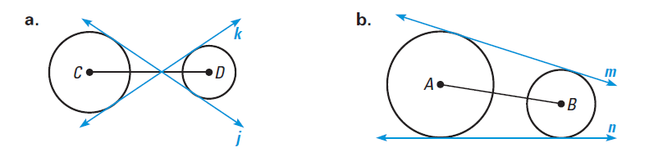

Example #3: Tell how many common tangents the circles have and draw them.

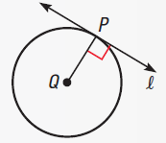
a. b. c.
Theorem 10.1:

In a plane, a line is ____________________ to a circle if and only if the line is

______________________ to a radius of the circle at its endpoint on the circle.

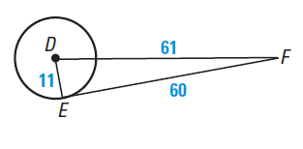
Example #4: Verify that $\overset{⃡}{EF}$ is tangent to $⨀{D}$

Example #5: You are standing at C, 8 feet from a grain silo. The distance from you to a point of tangency on the tank is 16 feet. What is the radius of the silo?
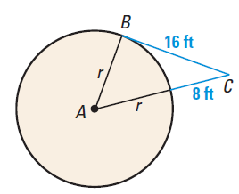

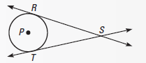
Theorem 10.2:

Tangent segments from a common external point are congruent.

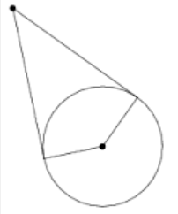
Example #6: $\overline{RS}$ is tangent to $⨀{C}$ at S and $\overline{RS}$ is tangent to $⨀{C}$ at T. Find the value of x
R
S
T
C
28
3x+4

Example #7:

Chapter 10.2: Find Arc Measures

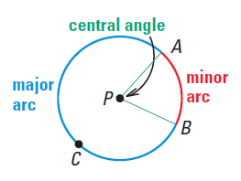
A central angle of a circle is an angle whose ________________
is the center of the circle.

If $m∠APB$ is less than ____________, then the points on $⨀P$ that lie in
the interior of $∠APB$ form a _______________________________
with endpoints A and B. (The measure of a minor arc is the measure of its central angle.)
Naming:

The points on $⨀P$ that do not lie on minor arc AB form a __________________________with endpoints A and B. (The measure of the entire circle is 360°. The measure of a major arc is the difference between 360° and the measure of the related minor arc)
Naming:

A _______________________________ is an arc with endpoints that are the endpoints of a diameter.

Example #1: For each arc of $⨀{.}$ Identify as a minor arc, major arc or semicircle and find its measure.
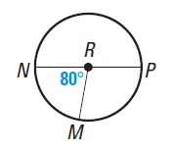
a.) mMN b.) mPMN

c.) mPM d.) mMPN
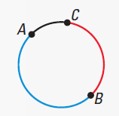
Two arcs of the same circle are adjacent if they intersect at exactly one point. You can add the measures of adjacent arcs.

Arc Addition Postulate (Postulate 26):

The measure of an arc formed by two adjacent arcs is the sum
of the measures of the two arcs.

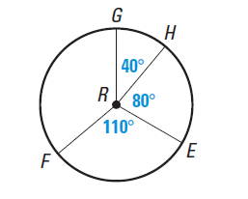
Example #2: Find the measure of each arc.

a. mGE b. mGEF

c. mGF d. mEFG

Two circles are congruent circles if they have the same _______________. Two arcs of the same circle or of congruent circles are congruent arcs if they have the _______________measure. So, two minor arcs of the same circle or of congruent circles are congruent if their central angles are _______________________.

Example #3: Are the given arcs congruent?

Chapter 10.3: Apply Properties of Chords

Recall: A chord is a segment with endpoints on a circle.
Because its endpoints lie on the circle, any chord
divides the circle into two arcs. A diameter divides
the circle into two ___________________________.
Any other chord divides a circle into a minor arc and a major arc.
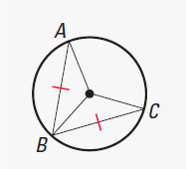
Theorem 10.3:

In the same circle, or in congruent circles, two minor arcs are congruent
if and only if their corresponding chords are congruent.

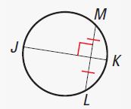
Theorem 10.4:

If one chord is a perpendicular bisector of another chord, then the first chord is a diameter.

If __________ is a perpendicular bisector of __________,

then __________ is a diameter of the circle.

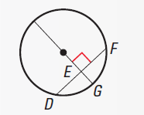
Theorem 10.5:
H

If a diameter of a circle is perpendicular to a chord, then the
diameter bisects the chord and its arc.

If __________ is a diameter and ______________________,

then ______________________ and ______________________,

Example #1: In the diagram, $⨀A≅⨀D, \overline{BC}≅\overline{EF}$, and $mEF=125°$. Find $mBC$.
C
A
B
E
F
125°
D

D
C
F
A
B
E
6
Example #2: Use the diagram of $⨀E$ to find the length of $\overline{BD}$.
Tell what theorem you use

Example #3: Find the measures of $m\hat{CB}$, $m\hat{BE}$, and $m\hat{CE}$
E
B
$$4x°$$
D
C
A

$$80-x°$$
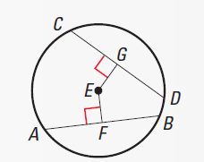
Theorem 10.6:

In the same circle, or in congruent circles, two chords are
congruent if and only if they are equidistant from center.

Example #4: In the diagram of $⨀F$, $AB=CD=12$. Find$EF$.
A
B
E
C
D
F
G
7x-8
3x
12
12

Example #5: In the diagram in Example 4, suppose $AB=27$ and $EF=GF=7.$ Find $CD$

Chapter 10.4: Use Inscribed Angles and Polygons
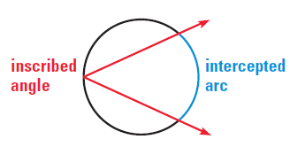
An inscribed angle is an angle whose vertex
is ON A CIRCLE’S EDGE and whose sides contain chords of the circle. The arc that lies in the interior of an inscribed angle and has endpoints on the angles is the
________________________________ of the angle.

Intercepted Arc is the ________________________________

Measure of an Inscribed Angle Theorem (Theorem 10.7):

The measure of an inscribed angle is one half
the measure of its intercepted arc.

$m∠ADB=$_______________

Example #1: Find the indicated measure in $⨀$ P.

a.) $m∠T$ b.) $mQT$

c.) $mST$ d.) $mQR$

Example #2: Find $mTSU$ and $m∠TSU$. What do you notice about $∠TSU$and $∠TRU$.

Theorem 10.8:

If two inscribed angles of a circle intercept the same arc, then the angles
are congruent.

$∠ADB≅$______________

Example #3: Name two pairs of congruent angles in the figure.

Checkpoint: Find the indicated measure.

1. $m∠HGF$ 2. $m∠ZXW$ 3. $mTV$

Theorem 10.9:
A
B
C

If a right triangle is inscribed in a circle, then the hypotenuse
is a ___________________ of the circle. Conversely, if one side of an
inscribed triangle is a diameter of the circle, then the triangle is a right
triangle and the angle opposite the diameter is the right angle.

$m∠ABC=___________$iff ________ is a diameter of $⨀D$.
A polygon is an inscribed polygon if all of its _____________________ lie on a circle. The circle
that contains the vertices a circumscribed circle.
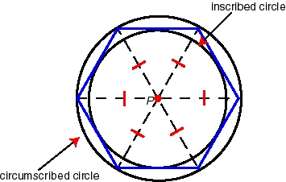
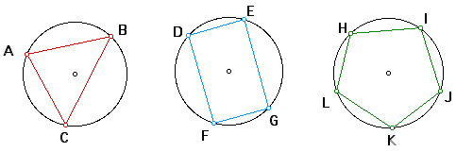

Theorem 10.10:

A quadrilateral can be inscribed in a circle iff its opposite
angles are _____________________________.

D, E, F and G lie on $⨀{C }$iff $m∠D+m∠F$ = ______________________________

Example #4: Find the value of each variable.
- b.

Example #5: A right triangle is inscribed in a circle. The radius of the circle is 5.6 cm. What is the length of the hypotenuse of the right triangle?

Chapter 10.5: Apply Other Angle Relationships in Circles

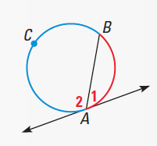
Theorem 10.11:

If a tangent and a chord intersect at a point on a circle,
then the measure of each angle formed is _____________
the measure of its intercepted arc.

$m∠1=$ _______________ $m∠2=$________________

Example #1: Line m is tangent to the circle. Find the measure of the red angle or arc.
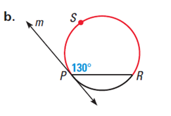
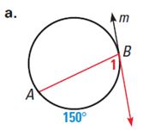

Intersecting Lines and Circles: If two lines intersect a circle, there are three places where the lines can intersect.
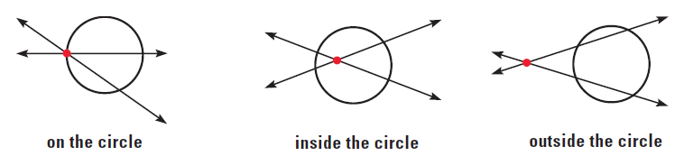

Angles Inside the Circle Theorem (Theorem 10.12):
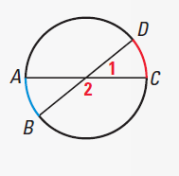
If two chords intersect inside a circle, then the measure
of each angle is one half the sum of the measures of the
arcs intercepted by the angle and its vertical angle.

$m∠1=$ _______________________

$m∠2=$________________________
Angles Outside the Circle Theorem (Theorem 10.13):

If a tangent and a secant, two tangents, or two secants intersect outside a circle, then the measure of the angle formed is one half the difference of the measures of the intercepted arcs.
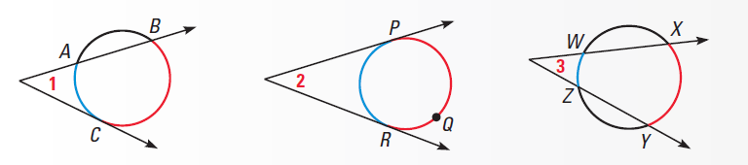

$m∠1=$ _____________________ $m∠2=$______________________ $m∠3=$______________________

Example #2: Find the value of x.
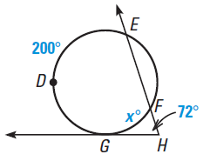
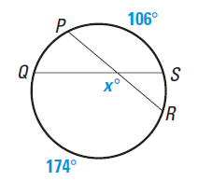
a. b.

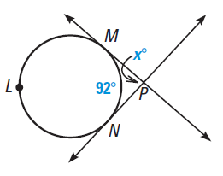
c.

Checkpoint: Find the missing angle or arc.

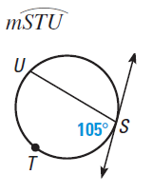
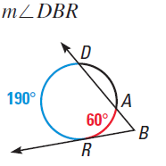
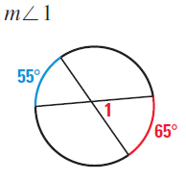
1. 2. 3.

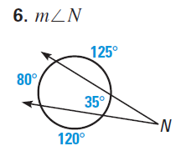
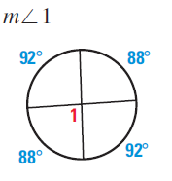
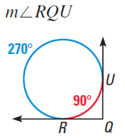
4. 5.

Chapter 10.6: Find Segment Lengths in Circles

** When two chords intersect in the interior of a circle, each chord is divided into two segments that are **

called ____________________________________________________

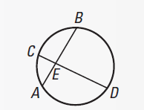
Segments of Chords Theorem (Theorem 10.14):

If two chords intersect in the interior of a circle, then the product of the lengths of the segments of one chord is equal to the product of the lengths of the segments of the other chord.

EA$∙$ EB = _________________

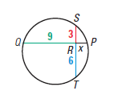
Example #1: Chords $\overline{ST}$ and $\overline{PQ}$ intersect inside the circle. Find the value of x.

L
K
M
J
x
$$x+3$$
$$x+5$$
$$x+1$$
N
Example #2: Find ML and JK

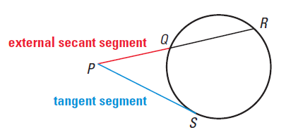
A __________________________________ is a segment that contains a chord of a circle, and has exactly one endpoint outside the circle. The part of the secant segment that is outside the circle is called an _________________________________________.

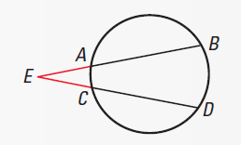
Segments of Secants Theorem (Theorem 10.15):

If two secant segments share the same endpoint outside a circle, then the product of the lengths of one secant segment and its external segment equals the product of the lengths of the other secant segment and its external segment.

EA$∙$ EB = _________________

Example #3: Find the value of x.
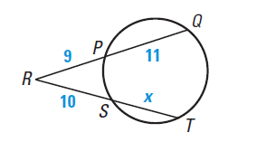

Segments of Secants and Tangents Theorem (Theorem 10.16):
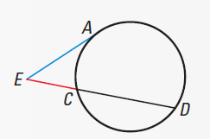
If a secant segment and a tangent segment share an endpoint outside a circle, then the product of the lengths of the secant segment and its external segment equals the square of the lengths of the tangent segment.

(EA$)^{2}$ = _________________

Example #4: Find the value of x.
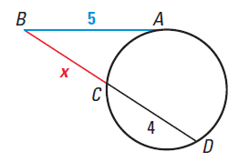
Checkpoint: Find the value of x.
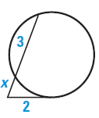
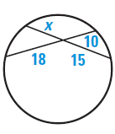
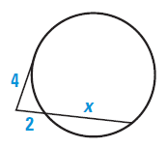
1. 2. 3.

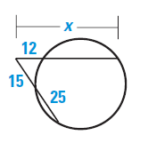
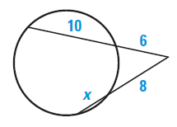
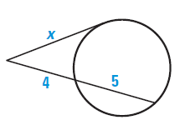
4. 5. 6.

Chapter 10.7: Write and Graph Equations of Circle

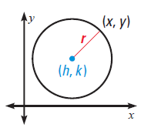
The Standard Equation of a Circle:

The standard equation of a circle with center (h, k) and radius r is:

Example #1: Write the standard equation of the circle with center (-4, 0) and radius 7.1.

Example #2: Write the standard equation of the circle with center (0, -5) and radius 3.7.

Example #3: Write the standard equation of the circle with center (-3, -5) and radius 6.1.

Example #4: Write the standard equation of the circles shown below.
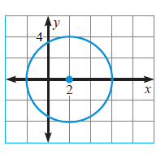
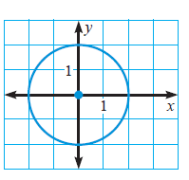
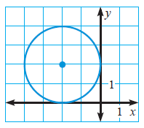
a. b. c.

Example #5: The point (1, 2) is on a circle whose center is (5, -1). Write the standard equation of the circle.

Example #6: The point (-3, 4) is on a circle whose center is (-1, 2). Write the standard equation of the circle.

Example #7: Graph the following circles using their given equations.
a. ${(x-2)}^{2}+{(y+3)}^{2}=16$

b. ${(x+5)}^{2}+{(y-5)}^{2}=9$

